Container Services:

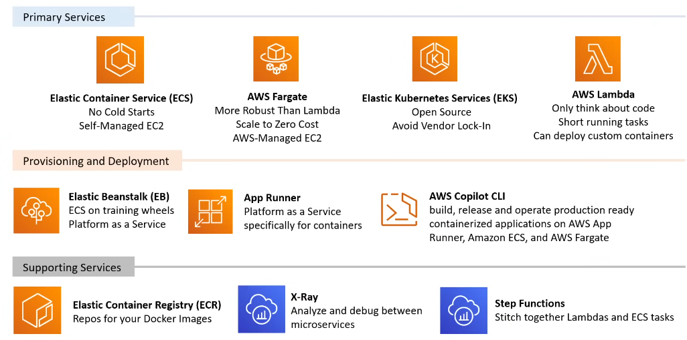

Primary Services:

**ECS (Elastic Container Service):**

* ECS is a fully managed container orchestration service that allows you to run Docker containers on a cluster of EC2 instances.
* It provides flexibility and control over the underlying infrastructure, allowing you to manage the EC2 instances running your containers.
* ECS is suitable for organizations that want more control over their container infrastructure or have specific requirements that ECS can address.
* It requires managing EC2 instances, including provisioning, scaling, and patching.

**AWS Fargate:**

* AWS Fargate is a serverless compute engine for containers that allows you to run containers without managing the underlying EC2 instances.
* With Fargate, you simply define your containerized applications, and AWS takes care of provisioning and managing the infrastructure.
* Fargate is suitable for organizations that want to run containers without worrying about server management, ideal for developers focused on building and deploying applications rather than managing infrastructure.

**EKS (Elastic Kubernetes Service):**

* Can be serverless if used with fargate else it is not serverless.
* EKS is a fully managed Kubernetes service that allows you to deploy, manage, and scale containerized applications using Kubernetes on AWS.
* It provides the flexibility and scalability of Kubernetes without the need to manage the Kubernetes control plane.
* EKS is suitable for organizations already using Kubernetes or those who prefer Kubernetes' declarative model for managing containers.
* It requires managing worker nodes (EC2 instances) unless using Fargate with EKS.

**AWS Lambda** :

Traditionally wasn't directly compatible with containers. However, in 2022, they introduced **container image support** for Lambda functions, offering new ways to leverage containers within the **serverless** Lambda environment. Here's how it works:

Concept:

* You package your application logic and dependencies as a container image (up to 10 GB).
* Instead of uploading code directly, you push your container image to an Amazon Elastic Container Registry (ECR) repository.
* When creating a Lambda function, you specify the URI of your ECR image instead of uploading code.

**AWS X-Ray** is a distributed tracing service provided by Amazon Web Services (AWS) that helps developers analyze and debug distributed applications, such as those built using microservices architecture. It provides insights into how components of an application are performing and interacting with each other, allowing developers to identify performance bottlenecks, troubleshoot errors, and optimize application performance. X-Ray allows you to trace requests as they travel through your application, providing a visual representation of the flow of requests across services and components. This helps in understanding how different parts of the application are interconnected and identifying potential points of failure or latency.

Organizations and Accounts:

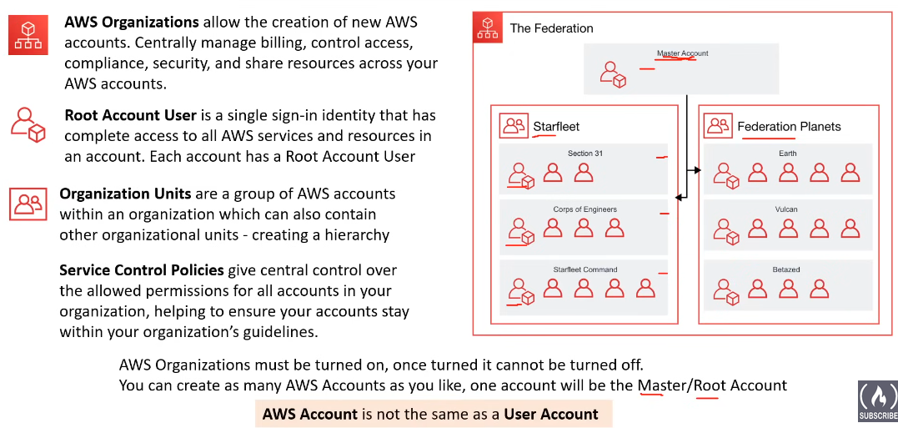

AWS Control Tower:

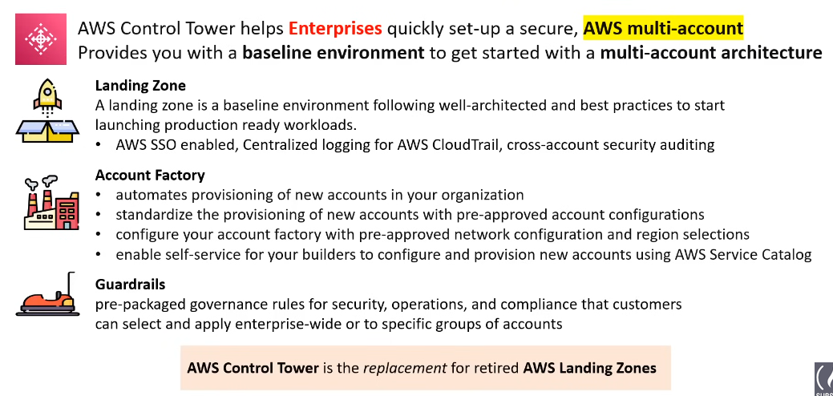

**AWS Control Tower** is a service that helps you set up and govern a secure, multi-account AWS environment based on best practices. It essentially simplifies the process of creating and managing a well-architected landing zone for your cloud deployments. Here's a breakdown of its key features:

**Simplified Setup:**

* Landing Zone: Control Tower automatically creates a landing zone with pre-configured accounts, IAM roles, and security controls, saving you time and effort.
* Best Practices: The landing zone adheres to AWS best practices for security, compliance, and governance, ensuring a solid foundation for your cloud infrastructure.
* Automation: Control Tower automates many tasks, including account creation, resource provisioning, and policy application, reducing manual work and potential errors.

**Enhanced Governance:**

* Guardrails: Control Tower implements pre-defined guardrails, which are essentially preventive and detective controls that help enforce your desired security and compliance posture.
* Centralized Management: You can manage your entire multi-account environment from a single dashboard, simplifying governance and policy enforcement.

When to Consider Using AWS Control Tower:

* If you are new to AWS and want a quick and secure way to get started.
* If you have a complex multi-account environment and need centralized management.
* If you want to ensure your cloud infrastructure adheres to best practices for security and compliance.

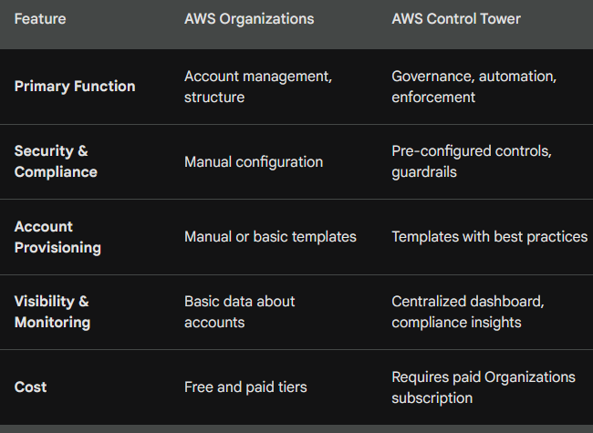

**Example of Control Tower:**

Let's consider an example of setting up a landing zone using AWS Control Tower for a fictional company named "ABC Corp".

1. Initial Setup:

* ABC Corp decides to use AWS Control Tower to establish a well-architected and governed AWS environment.
* The IT team initiates the setup process by accessing the AWS Control Tower console and providing necessary inputs such as company name, organizational structure, and account naming conventions.

2. Core Accounts Provisioning:

* AWS Control Tower automatically provisions the core AWS accounts:
* Master Account: This is the central administrative account for managing the entire AWS environment.
* Log Archive Account: Dedicated to storing logs and audit trails for compliance and monitoring purposes.

3. Account Structure Definition:

* ABC Corp defines an organizational structure based on business units and applications.
* For example, they create organizational units (OUs) named "Production", "Development", and "Testing".

4. Guardrails Implementation:

* AWS Control Tower applies guardrails to enforce security, compliance, and operational controls across all accounts within the landing zone.
* For example, they configure guardrails to enforce encryption for data at rest, require multi-factor authentication (MFA) for privileged access, and restrict public access to certain AWS services.

After the setup of the landing zone is complete, ABC Corp can start deploying their workloads and applications within the governed AWS environment. The landing zone provides a secure and compliant foundation, allowing ABC Corp to focus on building and scaling their AWS workloads while adhering to best practices and security standards.

AWS Config:

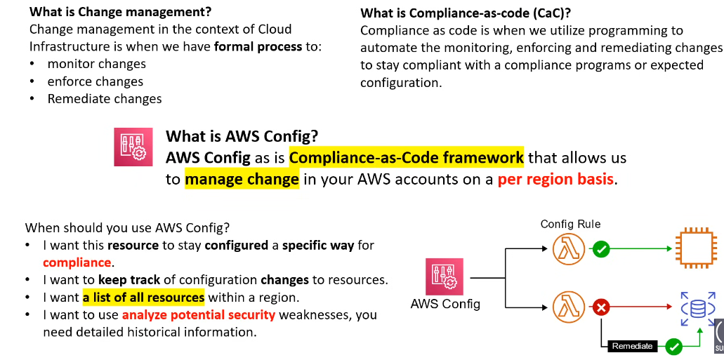

AWS Quick Starts:

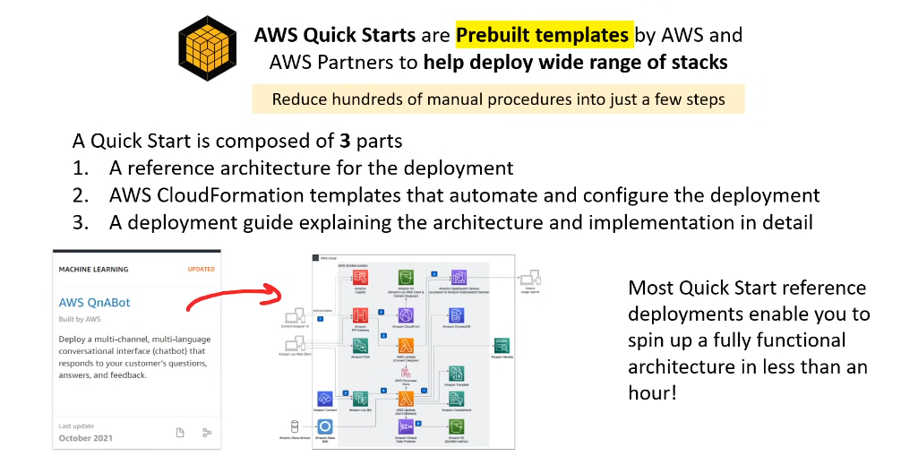

Tagging:

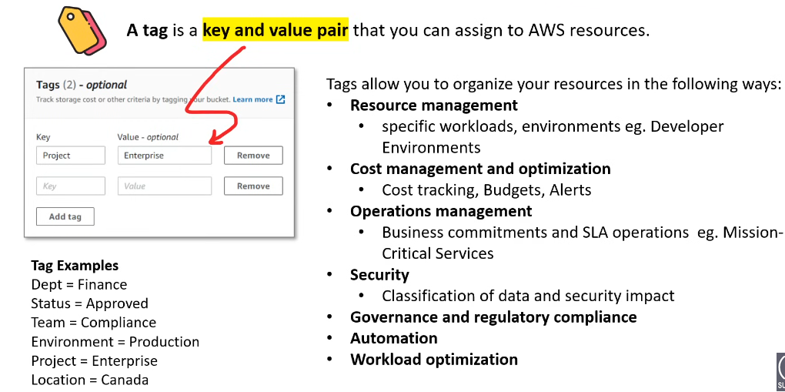

Resource Groups:

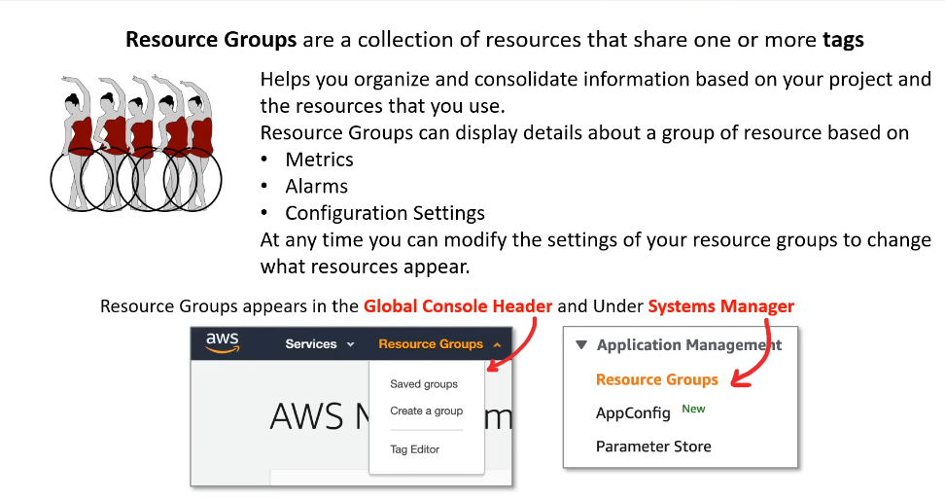

Business Centric Services:

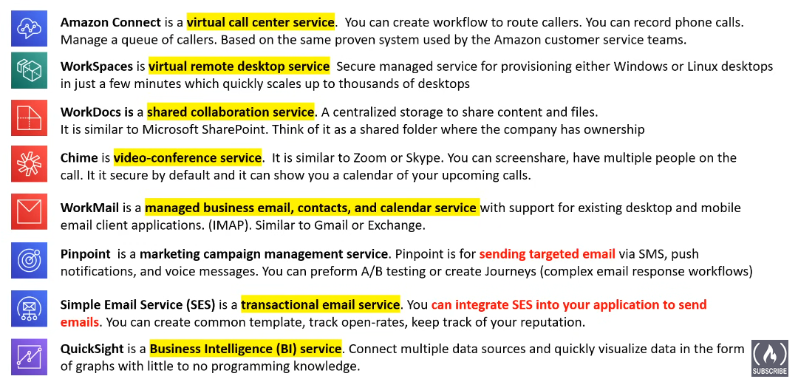

Provisioning Services:

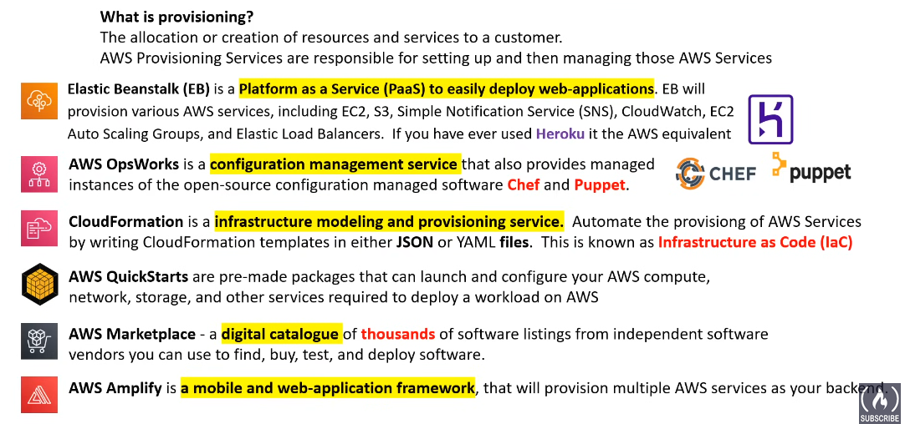

* AWS Amplify can only provision serverless services like fargate, dynamo db. etc.

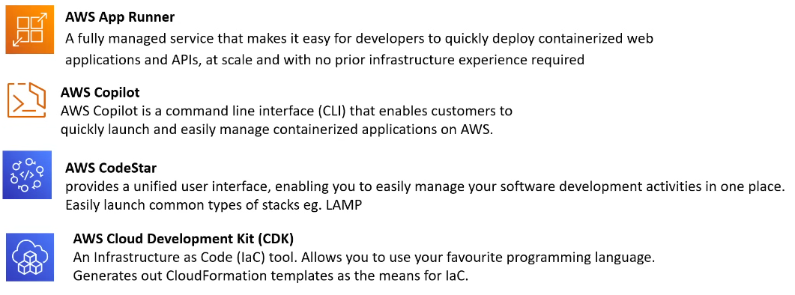

**AWS OpsWorks** is a configuration management service provided by Amazon Web Services (AWS) that helps you automate the deployment, configuration, and management of applications and infrastructure on AWS. OpsWorks supports a variety of application architectures and frameworks, making it suitable for a wide range of use cases.

**Key features of AWS OpsWorks include:**

* **Configuration Management**: OpsWorks allows you to define the configuration of your applications and infrastructure using Chef, an automation platform that uses code (in the form of recipes and cookbooks) to describe how systems should be configured. You can use built-in Chef cookbooks or create custom ones to define the desired state of your resources.

**AWS CodeStar** is a cloud-based development service that provides tools and resources to develop, build, and deploy applications on AWS quickly and easily. It helps developers manage the entire application development process, from code commit and build to deployment and monitoring.

AWS Elastic Beanstalk: 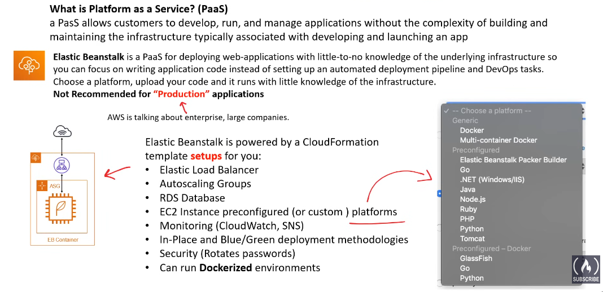

What is Serverless ?

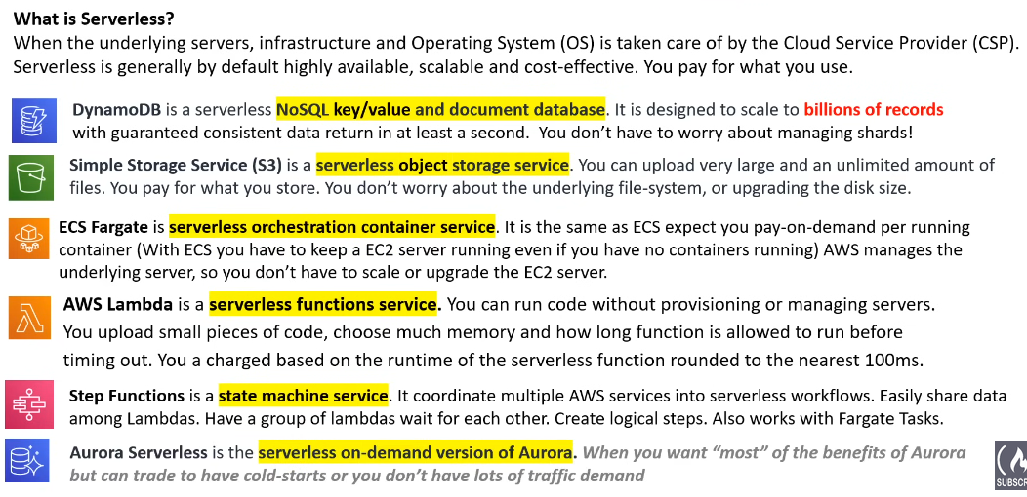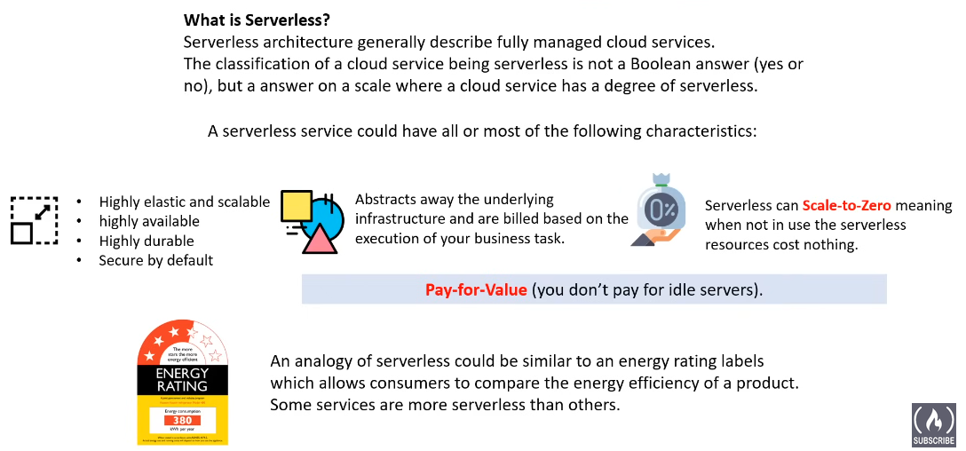

Windows on AWS: 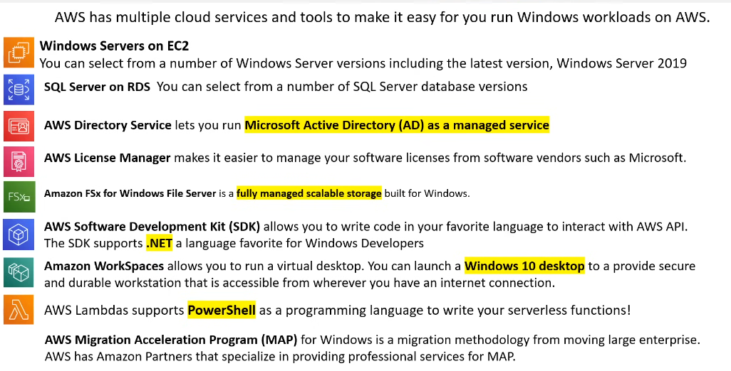

AWS License Manager: 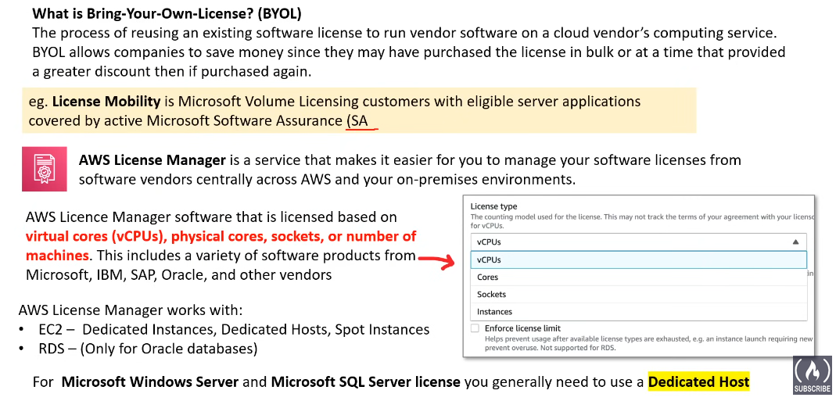

Logging Services:

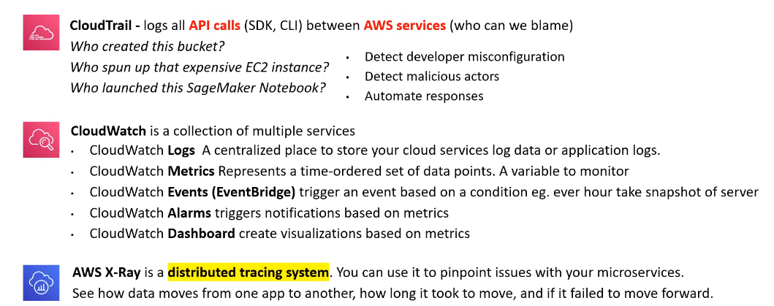

AWS CloudTrail:

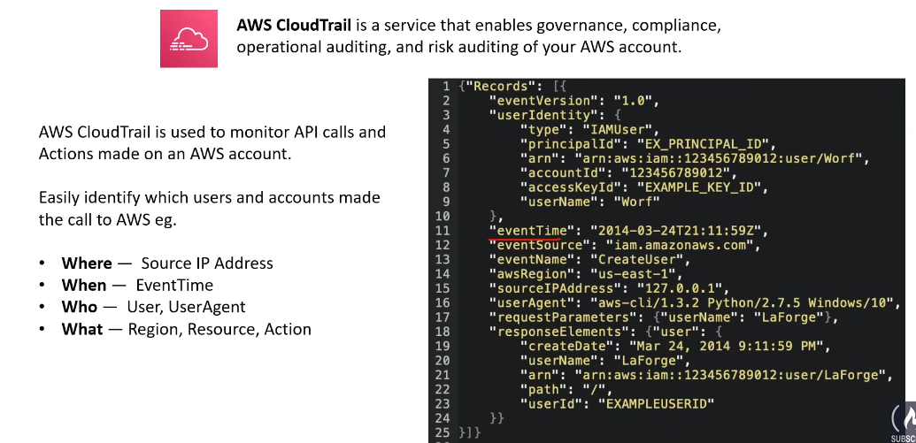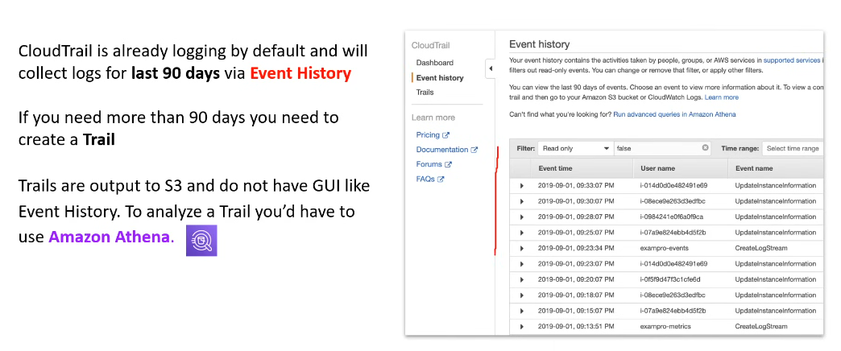

CloudWatch Alarm:

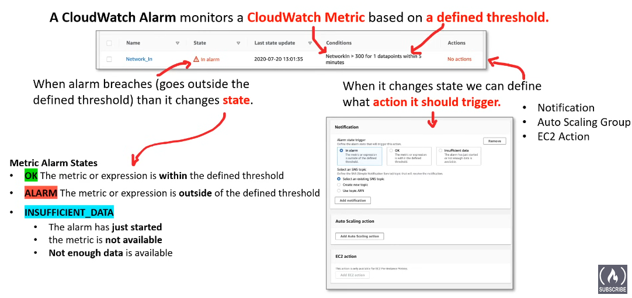

* Anatomy of an Alarm: 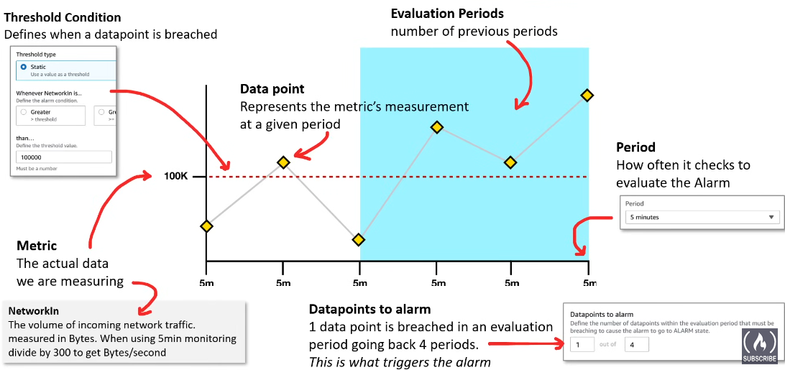

CloudWatch Logs:

* Log Streams:

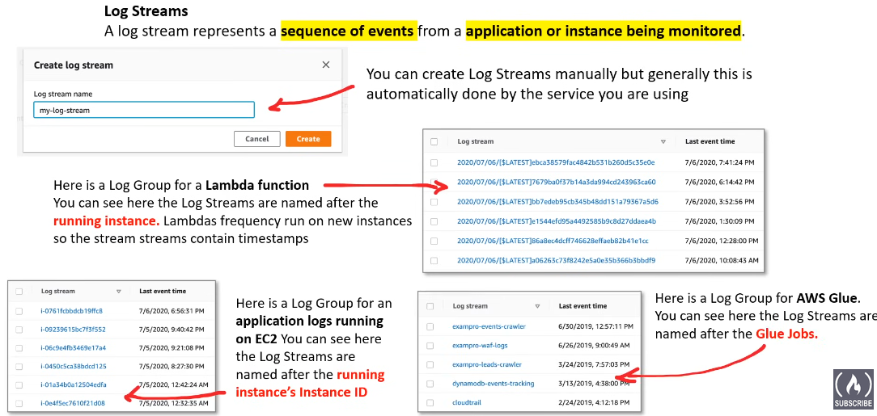

* Log Events: 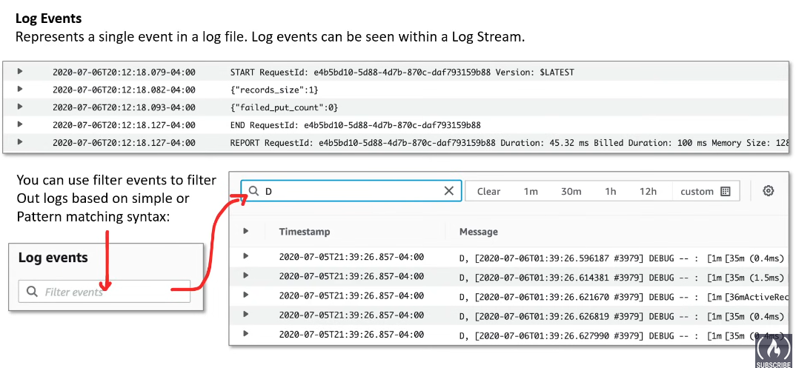
* Log Insights: 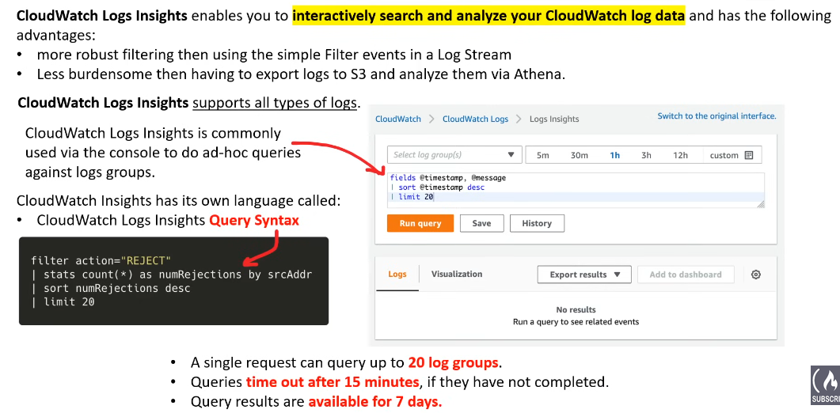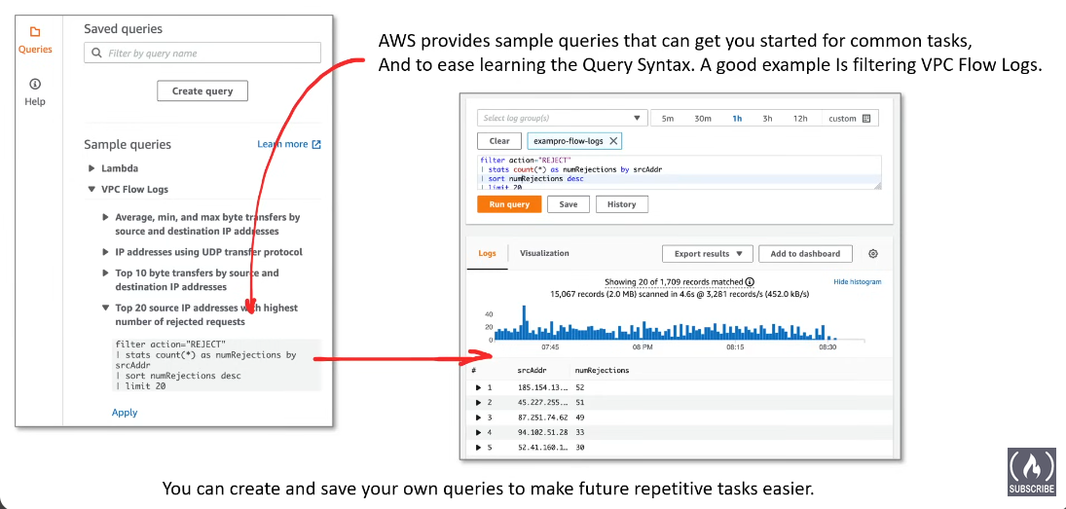

CloudWatch Metrics: 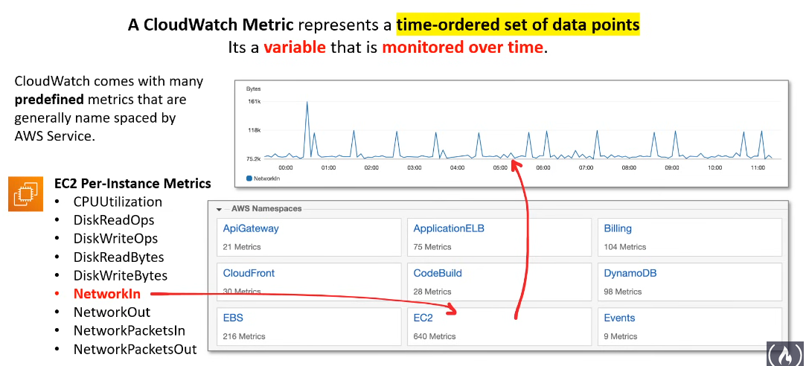

AWS Machine Learning and AI Services: 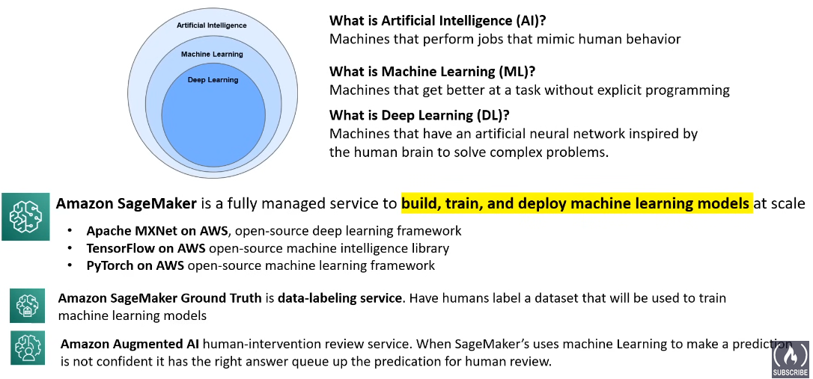

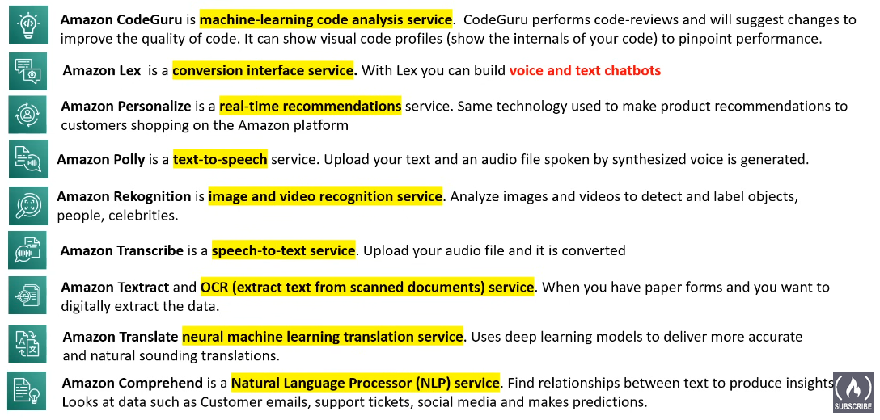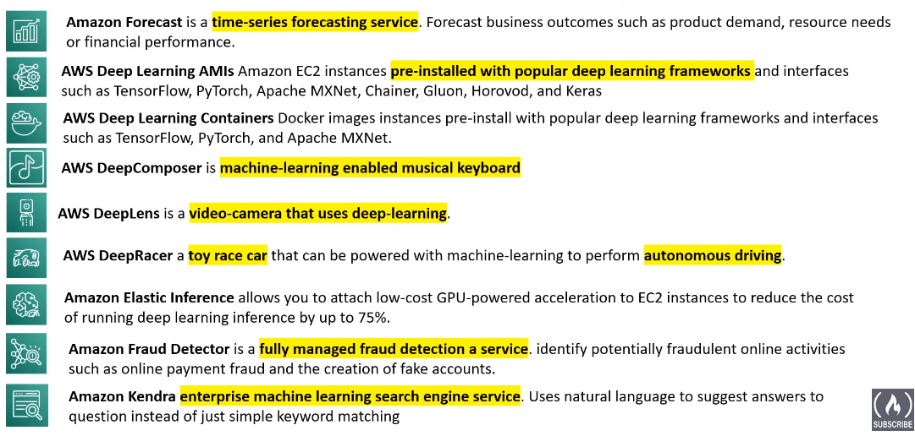

Big Data and Analytical Services: 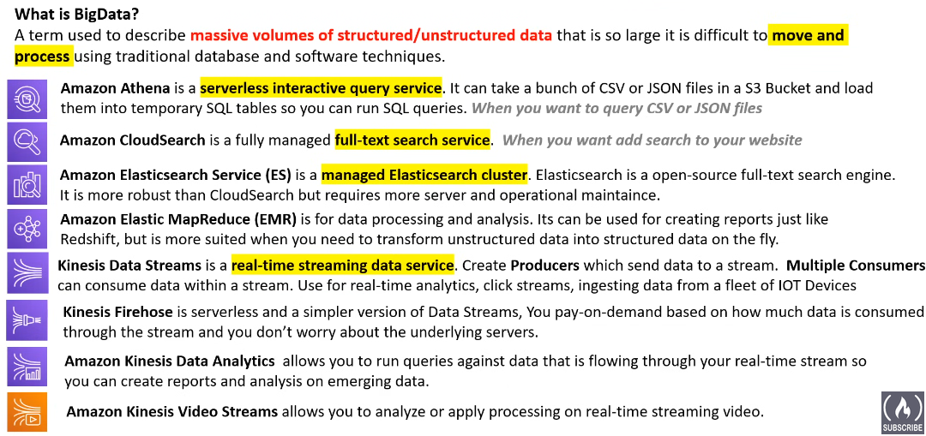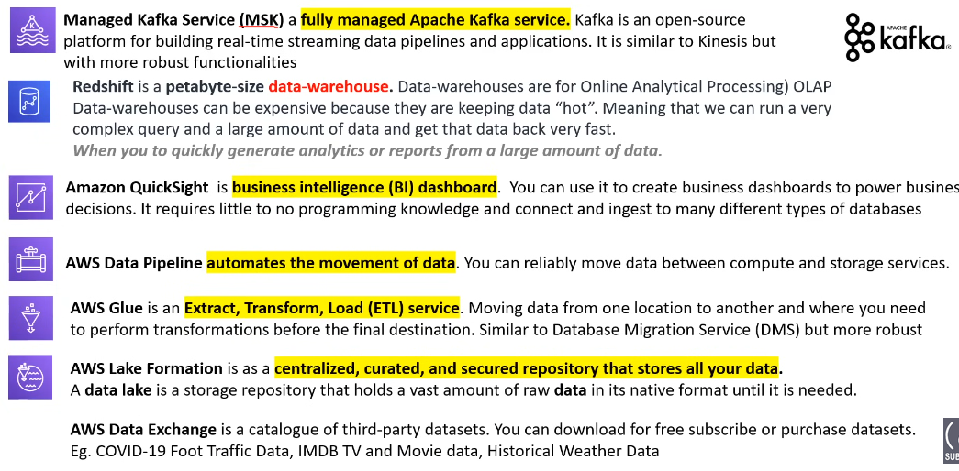

AWS QuickSight:

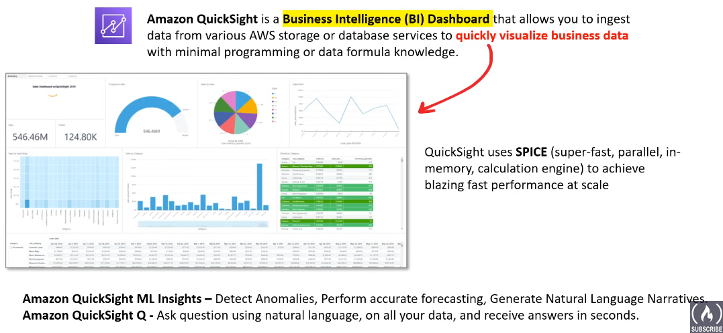

More ML and AI Services:

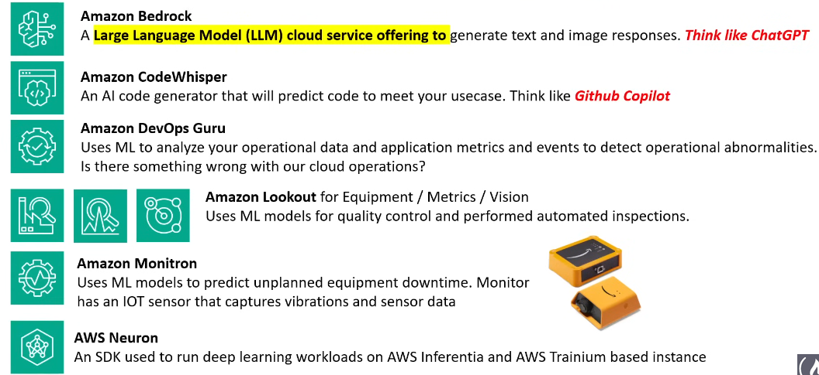

Generative AI:

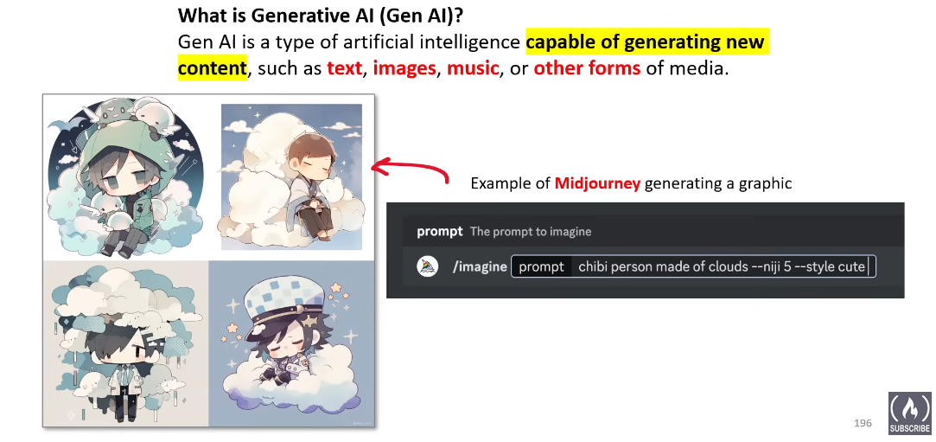

ML and DL Frameworks and Tools:

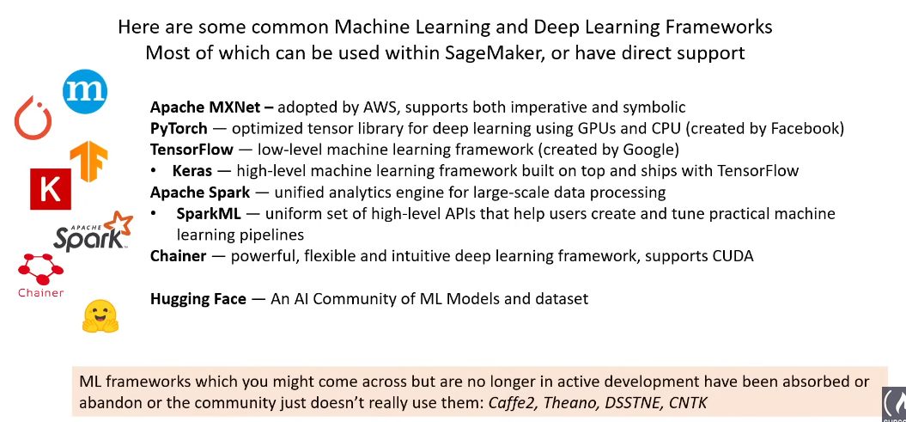

Apache MXNet:

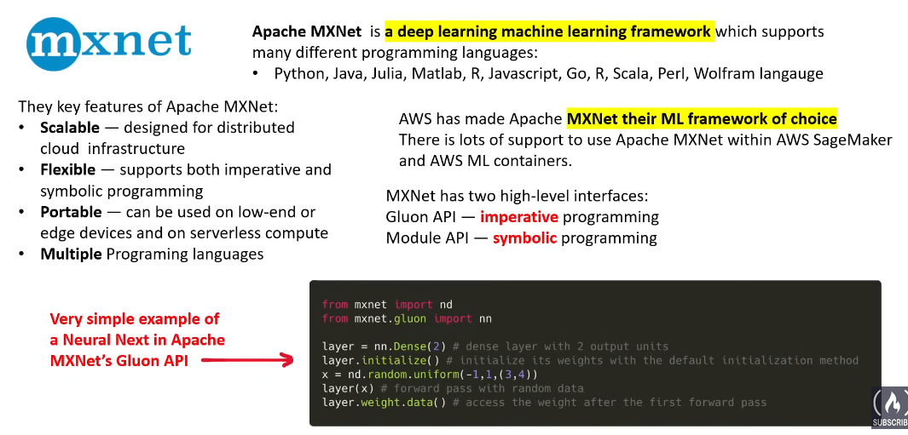

What is Intel:

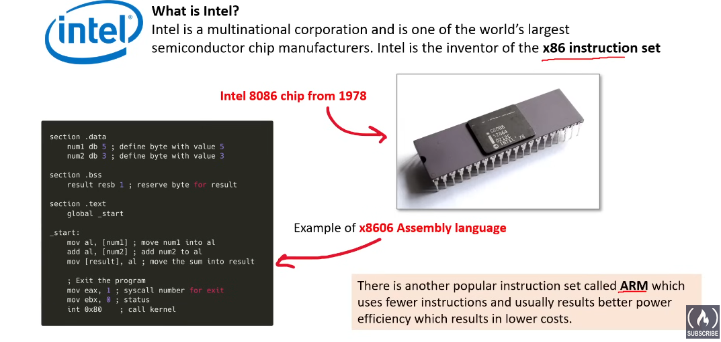

Intel Xeon Scalable and Intel Gaudi:

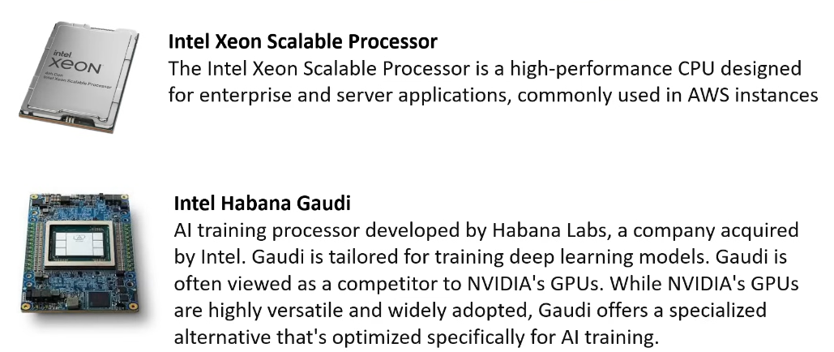

What is a GPU:  
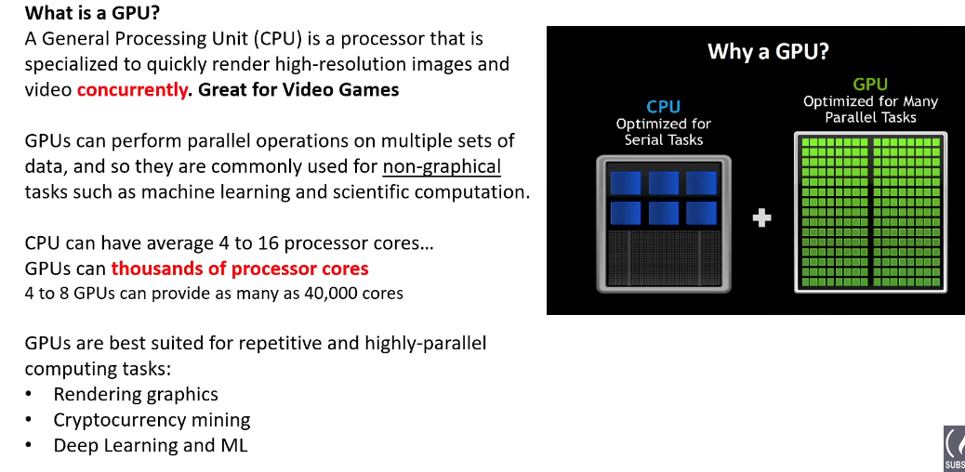

What is CUDA?

CUDA, which stands for **Compute Unified Device Architecture**, is like a special translator for your computer. It helps your computer talk to and use powerful processors called **Graphics Processing Units (GPUs)** for tasks beyond just graphics.

Imagine you have a regular CPU (Central Processing Unit) like the main brain in your computer. It's good at doing many things at once, but each task takes a tiny bit of time. Now imagine a GPU, like a team of super-fast specialists. They can do specific tasks much faster than the CPU, but they need clear instructions to understand what to do.

**That's where CUDA comes in!** It translates the instructions from your computer programs into a language the GPU understands. This allows the GPU to take over certain tasks, freeing up the CPU for other things. It's like giving the specialists the right tools and instructions so they can work their magic without needing the main brain to do everything at once.

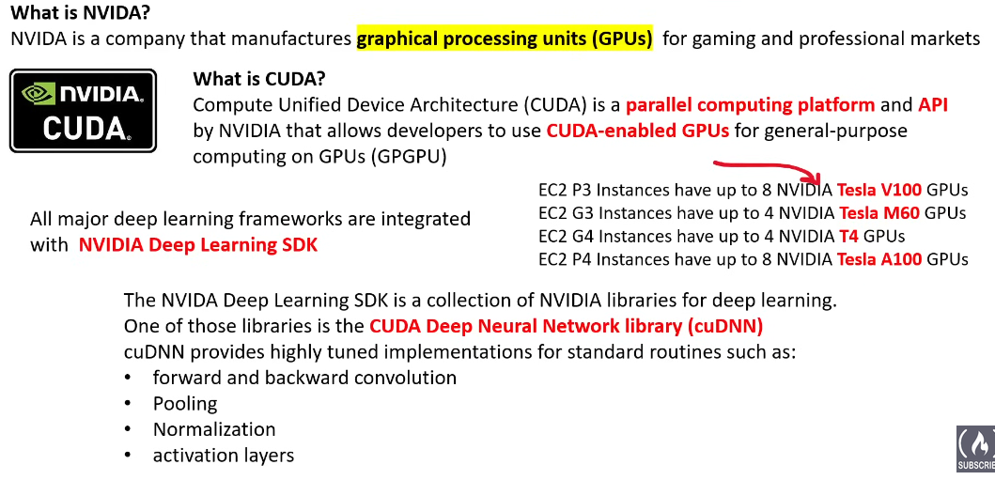

AWS Well-Architectured Framework: 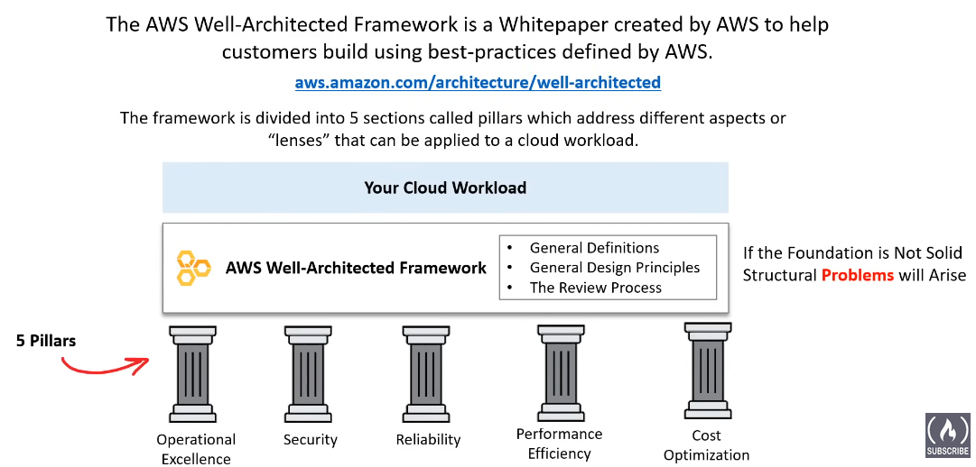

* General Definitions:

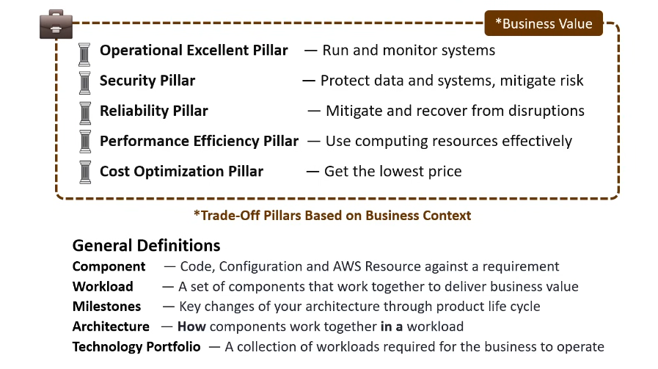

* **Component**: Think of it as a small part of a bigger machine. In the context of technology, it could be a piece of code, a setting, or a resource provided by AWS (Amazon Web Services) that fulfills a specific task or requirement.
* **Workload**: This is the total amount of work that needs to be done to achieve a specific goal. In tech terms, it's a group of components (those small parts we talked about earlier) working together to deliver something valuable, like a feature in an app.
* **Milestones**: These are like checkpoints in a video game. They represent key moments or changes in your project's life cycle. For example, completing a major feature could be a milestone.
* **Architecture**: This is the blueprint of your project. It's a plan that shows how different components (those small parts again) work together in a workload (the total work to be done).
* **Technology Portfolio**: This is like a toolbox for your business. It's a collection of all the workloads (all the different sets of work) that your business needs to operate.

ON Architecture: 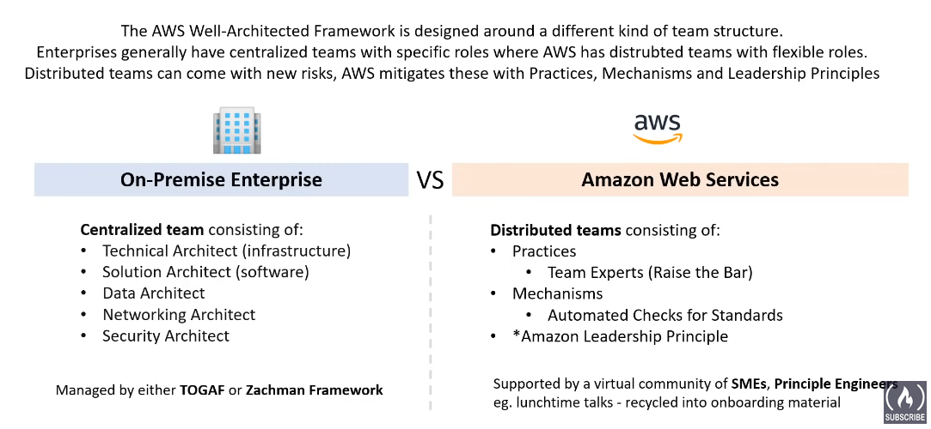

Amazon Leadership Principles: 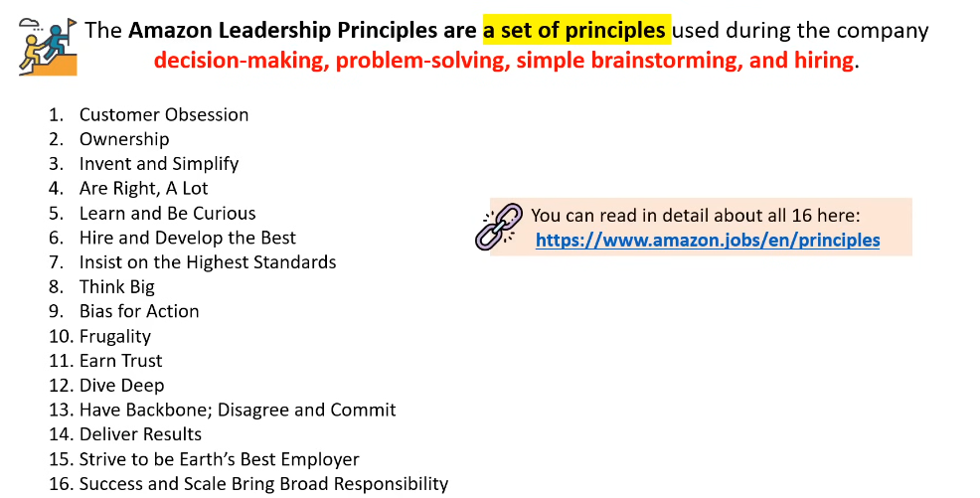

General Design Principles:

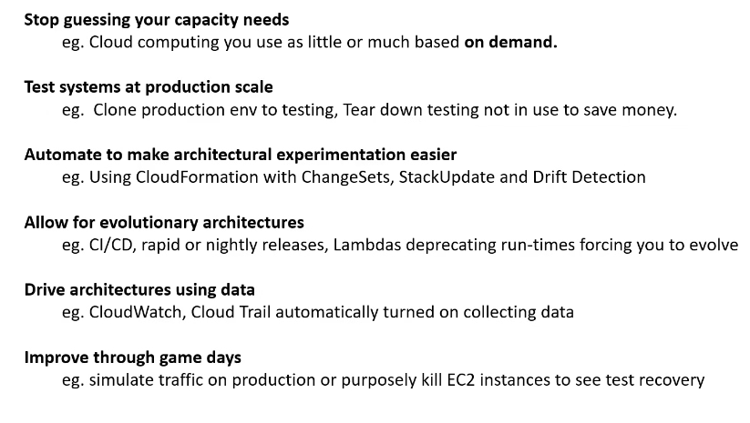

Anatomy of Pillar:

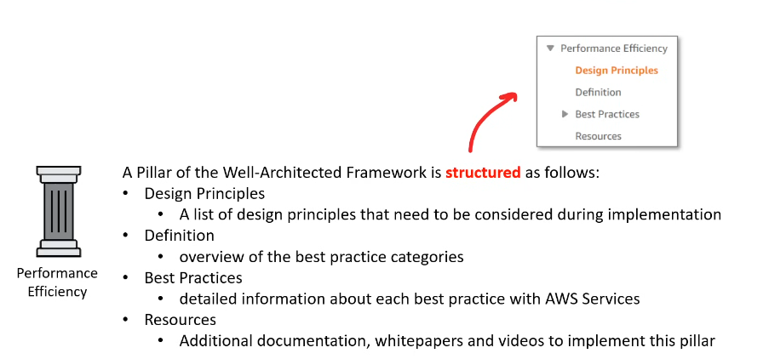

1. Operational Excellence Pillar:

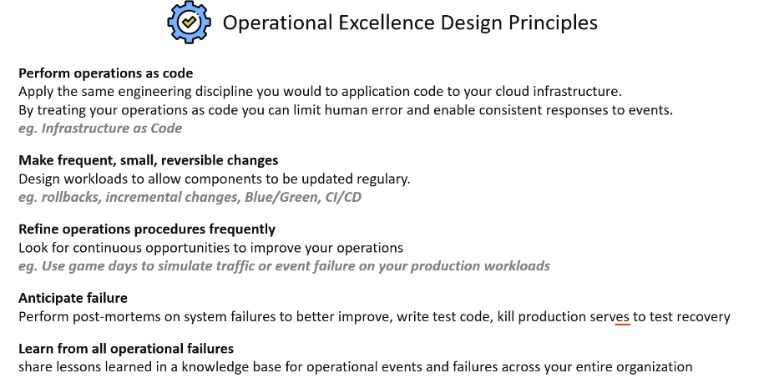

2. Security Pillar:

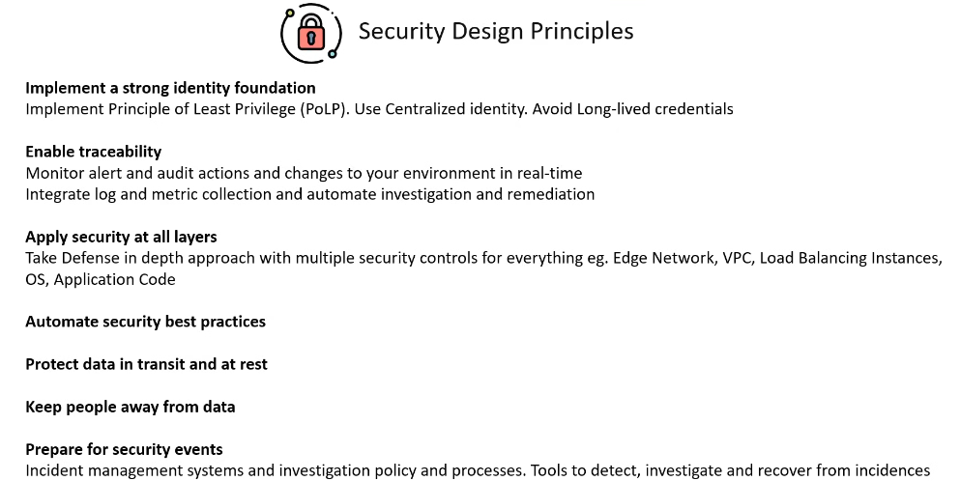

3. Reliability Pillar: 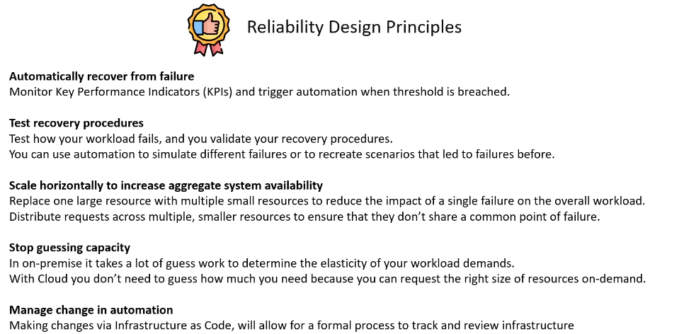

4. Performance Efficiency Pillar:

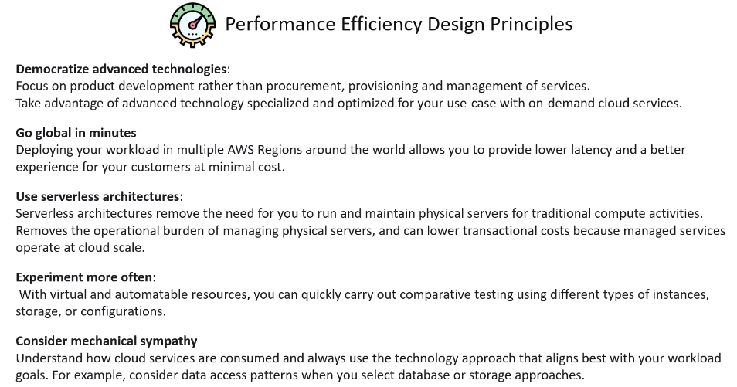

5. Cost Optimization Pilar:

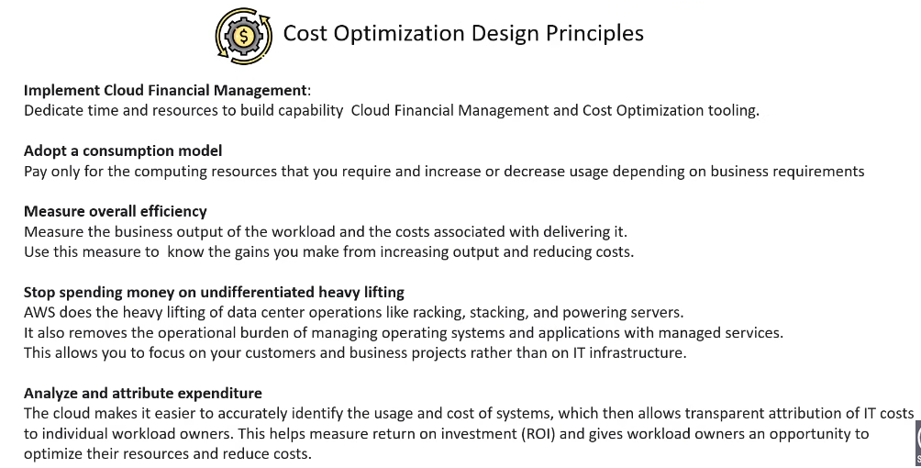

AWS Well Architectured Tool:

The AWS Well-Architected Tool is a service provided by Amazon Web Services (AWS) that helps users design and implement well-architected solutions on the AWS platform. It offers a structured approach to evaluate workloads and applications based on AWS best practices and architectural principles. The tool provides guidance on how to improve various aspects of your architecture, such as security, reliability, performance efficiency, cost optimization, and operational excellence.

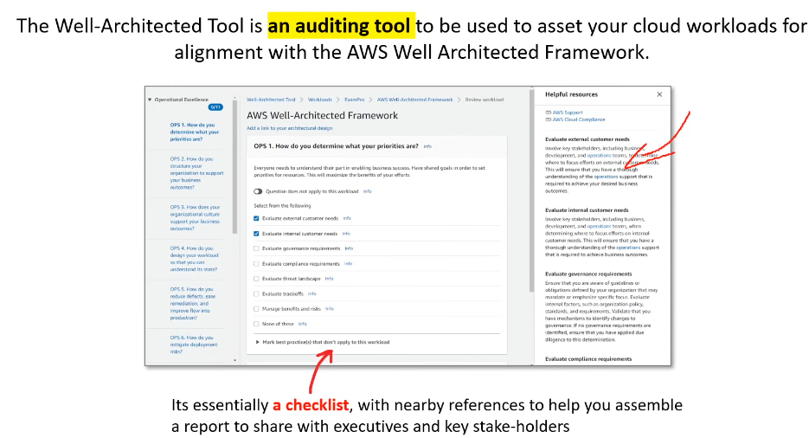

AWS Architecture Center:

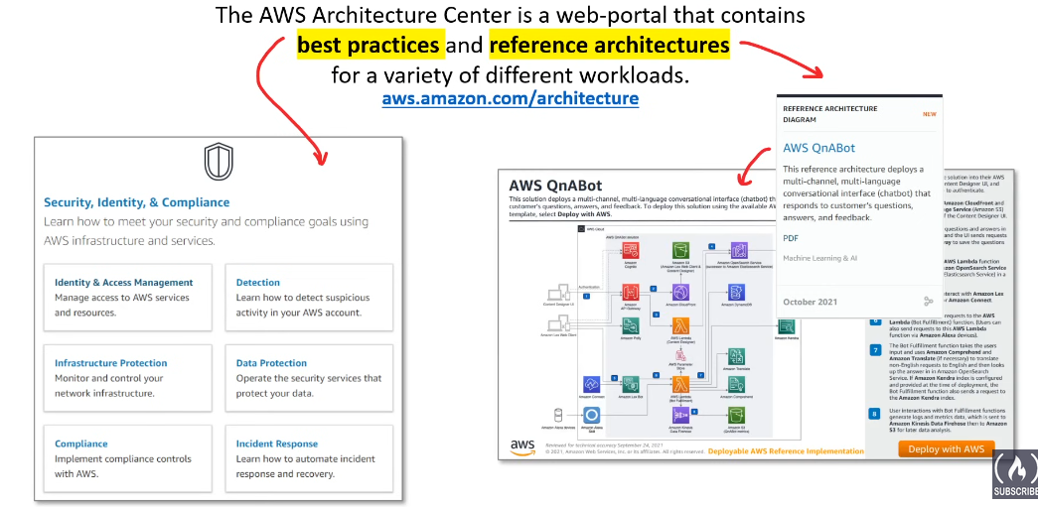

TCO and Migration:

* Total Cost of Ownership: 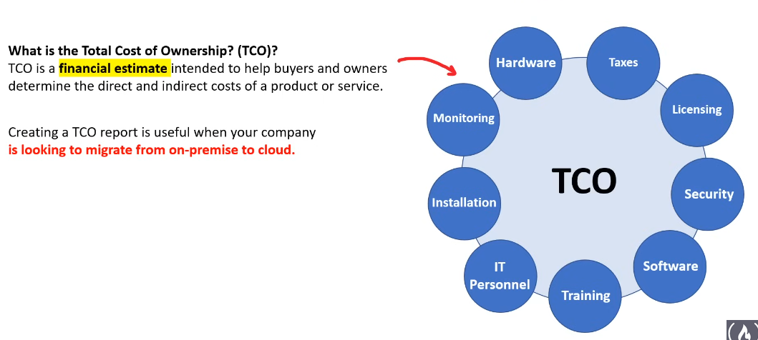

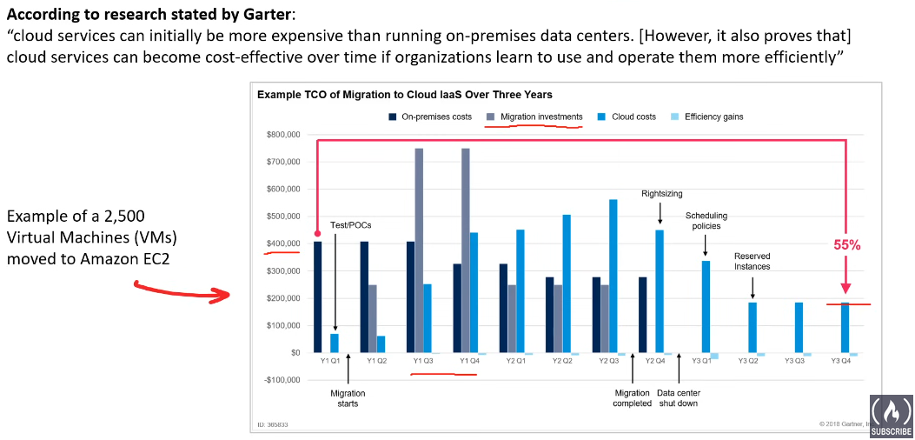 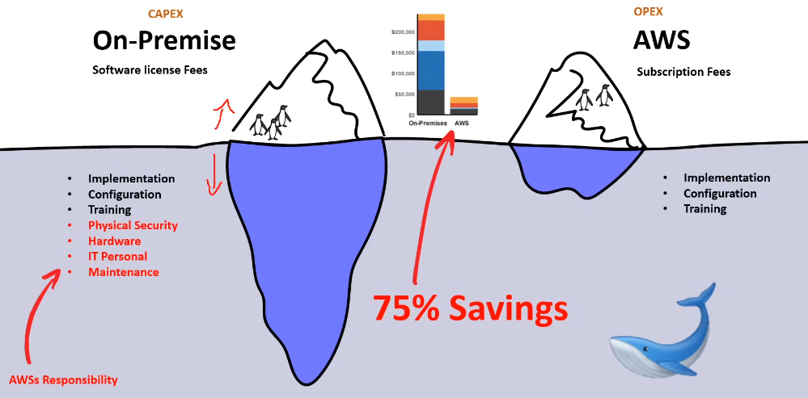

* Capital vs Operational Cost:

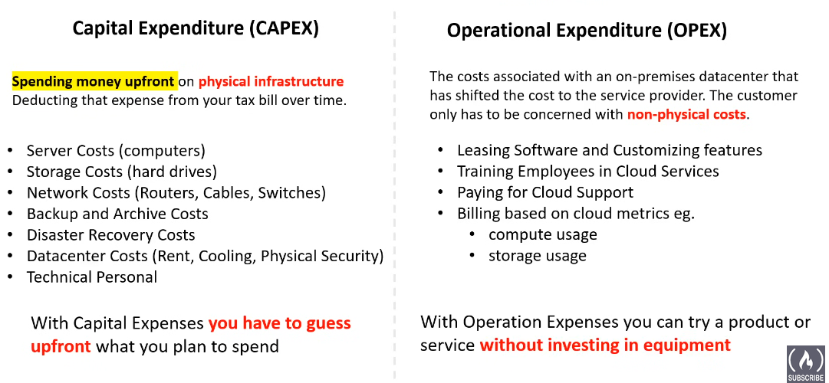

* Shifting IT Personnel: 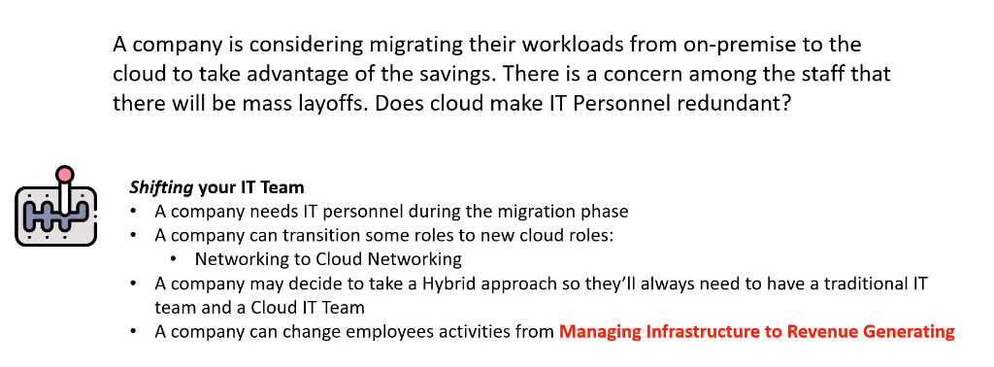
* AWS Pricing Calculator:

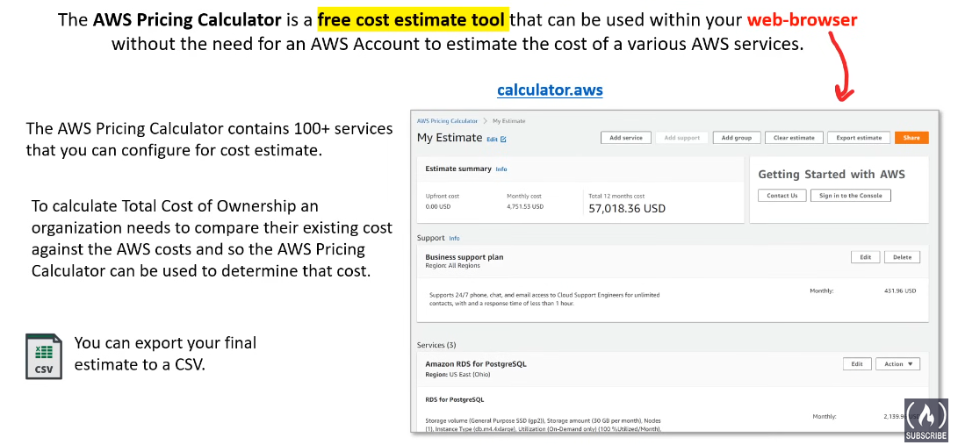

* Migration Evaluator: 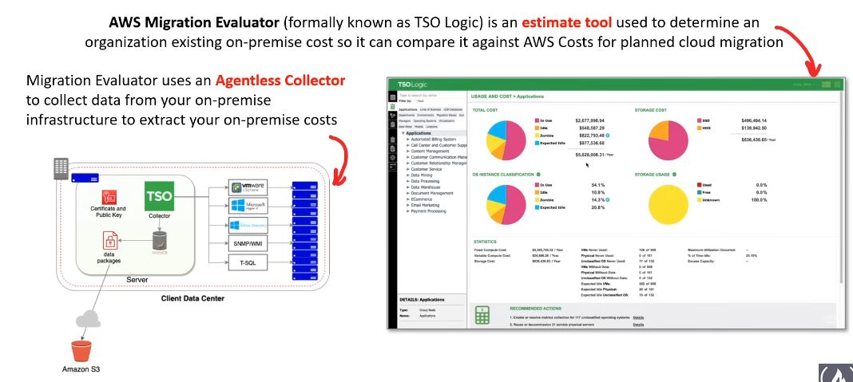
* VM Import Export: 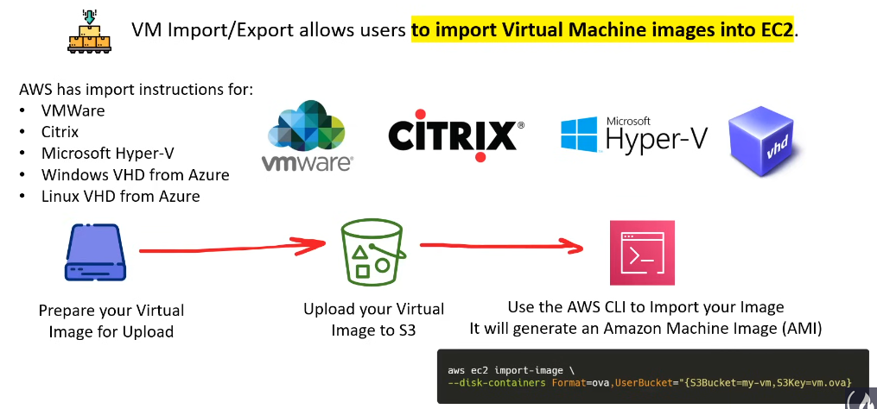
* Database Migration Service: 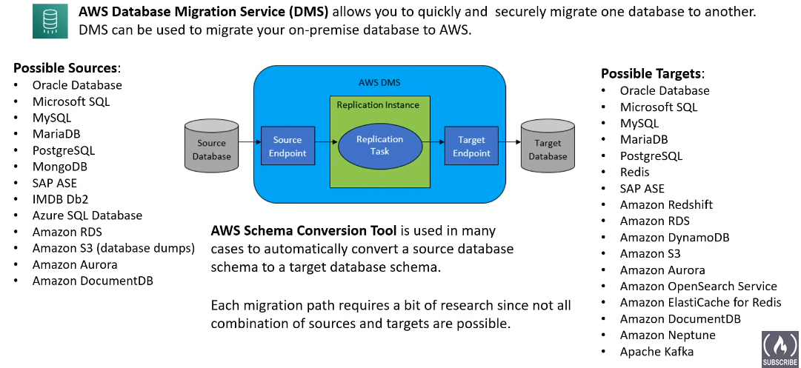
* Cloud Adoption Framework: 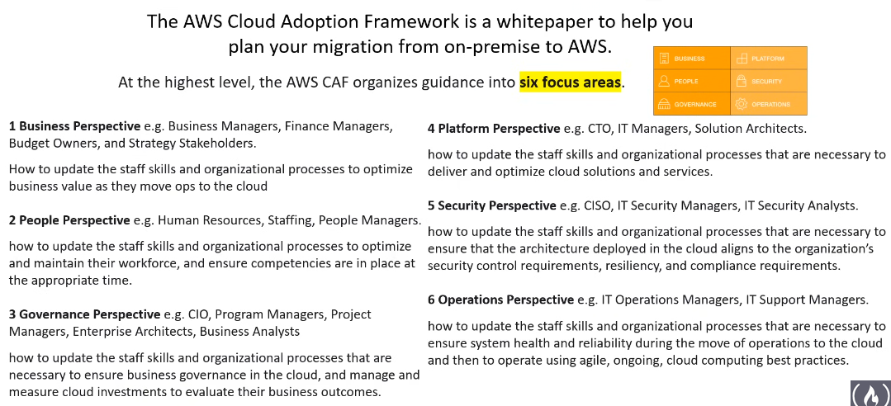

AWS Free Services:

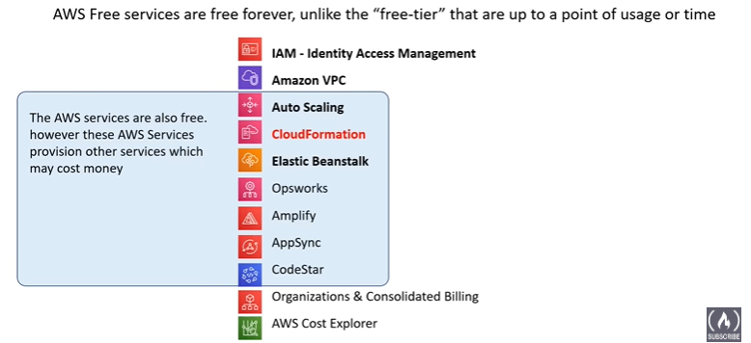

AWS Support Plan:

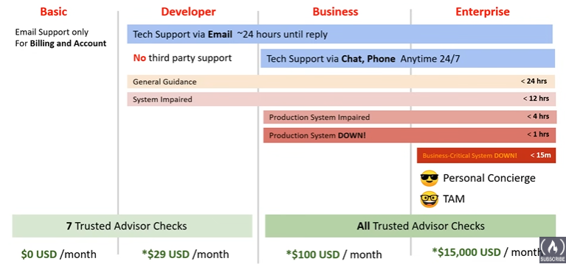

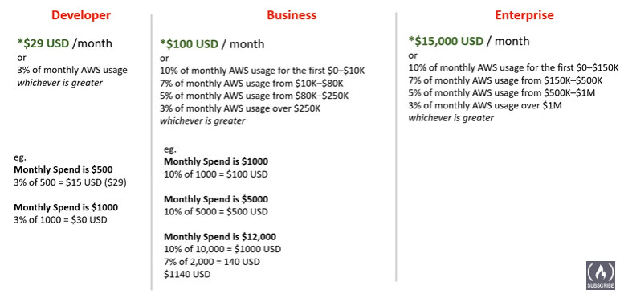

Technical Account Manager:

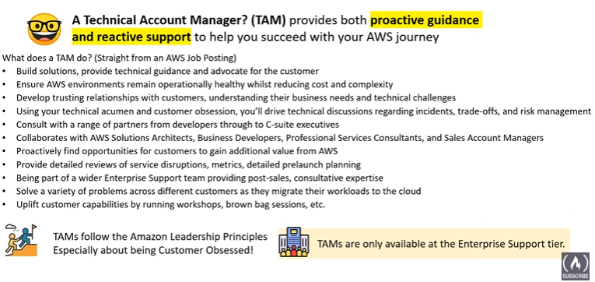

AWS Marketplace: 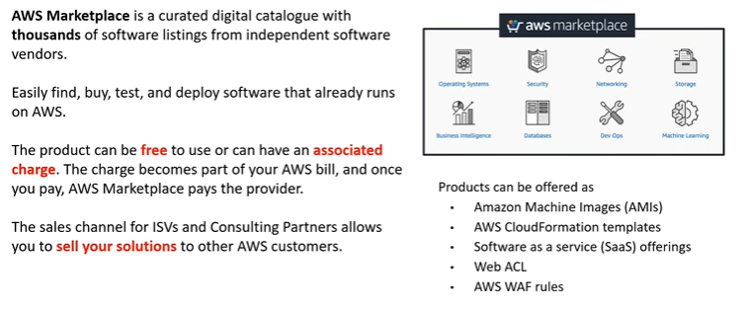

Consolidated Billing: 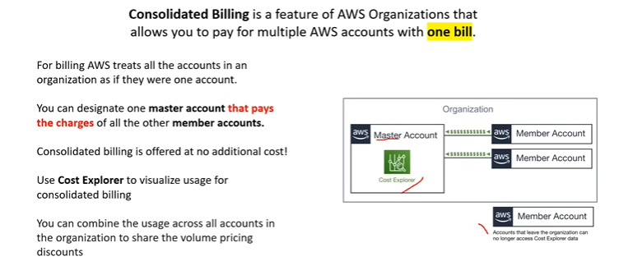

Consolidated Billing Volume Discount: 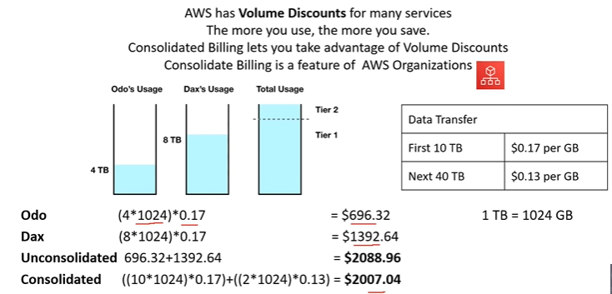

AWS Trusted Advisor:

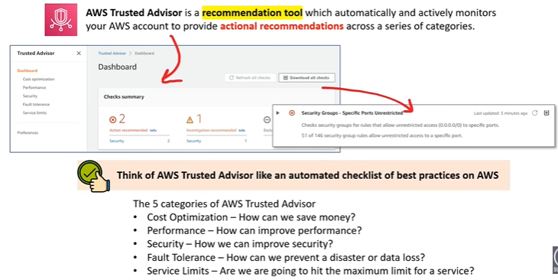

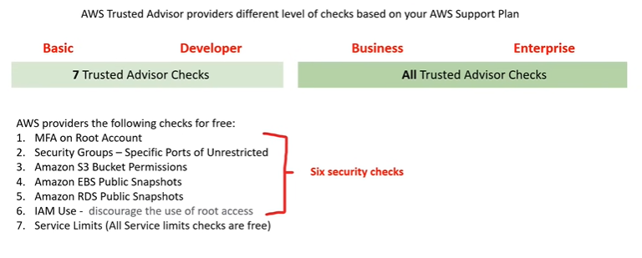

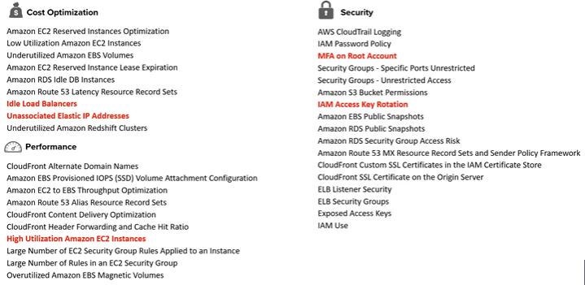

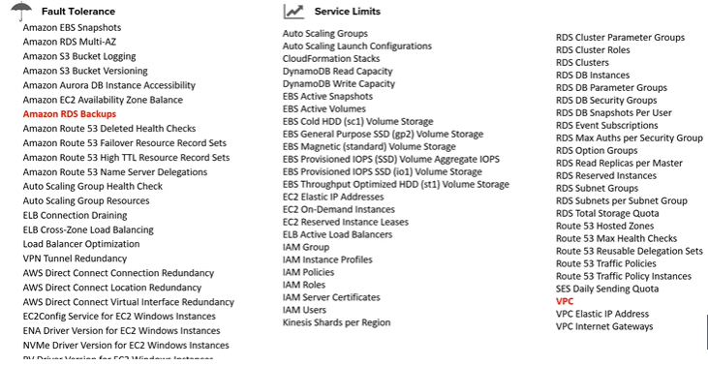

**SLA (Service Level Agreement):**

This is like the promise the pizza place makes to you. They might say, "Your pizza will be delivered within 30 minutes, or you get a free side dish!" This is a formal agreement with specific terms.

**SLO (Service Level Objective):**

This is the goal the pizza place sets for itself internally to keep their promise. They might aim for a delivery time of 28 minutes to ensure they're almost always under the 30-minute guarantee. This is a target they strive for.

**SLI (Service Level Indicator):**

This is how they track their progress towards that goal. They might measure the actual average delivery time each day. This is the data that shows them if they're meeting their objective.

Here's the breakdown:

* SLA: The external promise made to customers.
* SLO: The internal target set to achieve the SLA.
* SLI: The measurement used to track progress towards the SLO.

So, in simpler terms:

* SLA: The guaranteed service level (e.g., pizza delivery time)
* SLO: The target to meet the guarantee (e.g., aim for faster delivery)
* SLI: The data showing if the target is being met (e.g., actual delivery time)

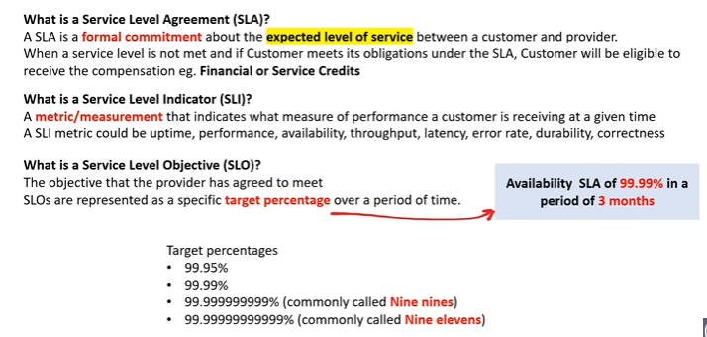

AWS SLA’s Example: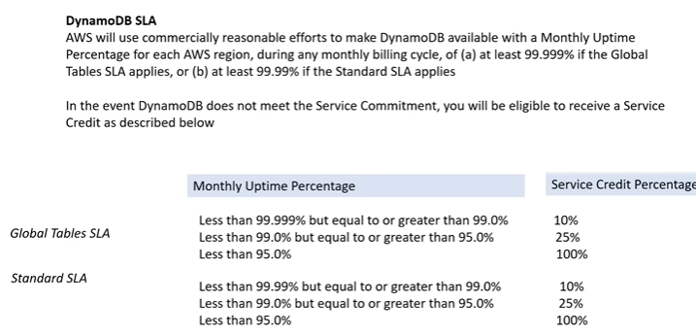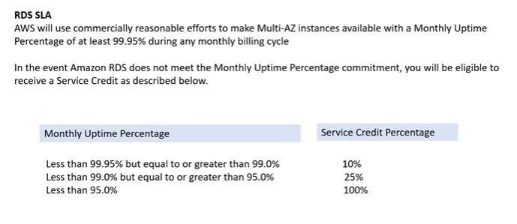 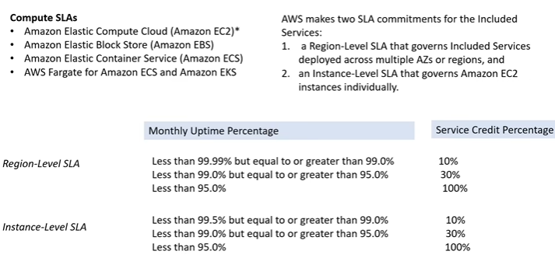

AWS Service Health Dashboard: 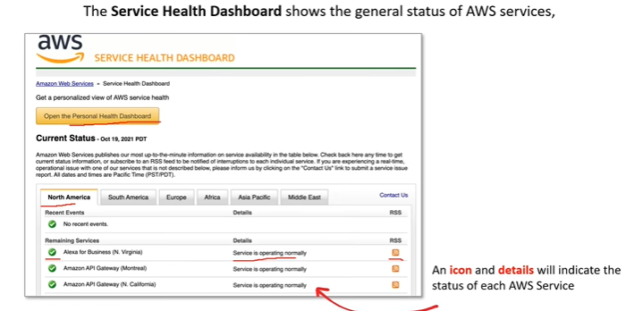

AWS Personal Health Dashboard:

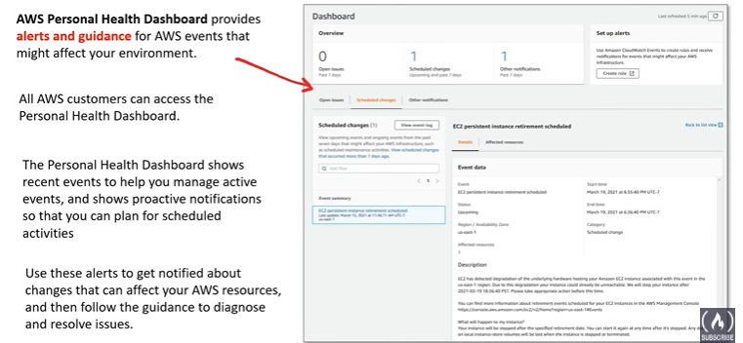

AWS Abuse:

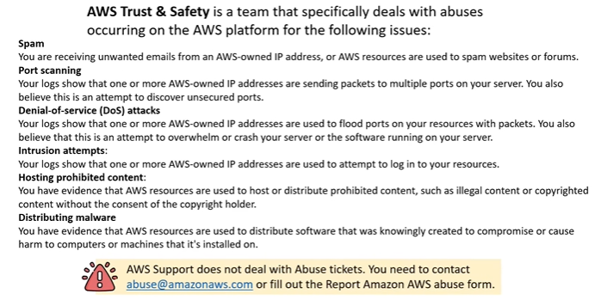

AWS Free Tier:

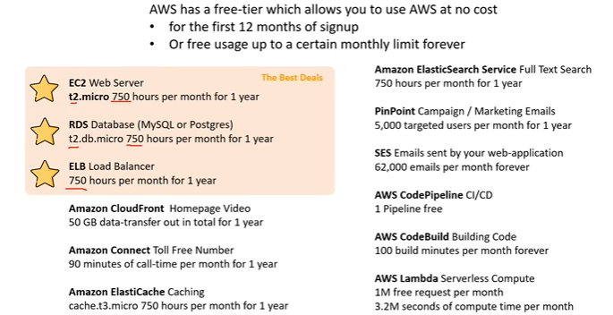

AWS Credit:

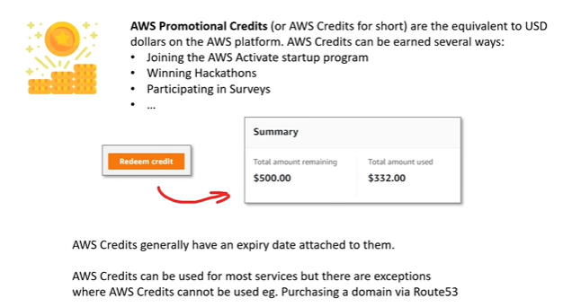

AWS Partner Network (APN): 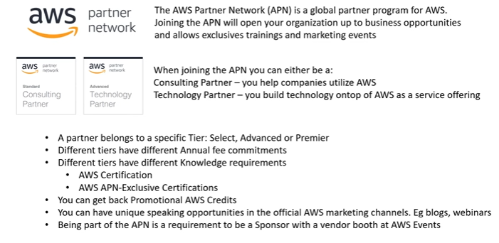AWS Budgets: 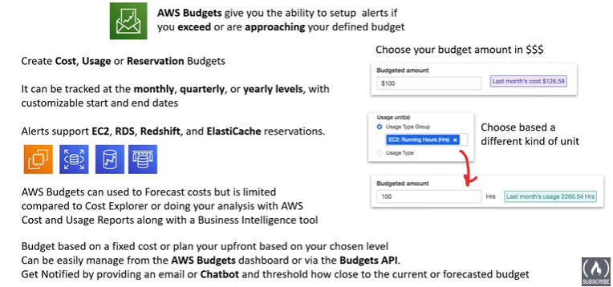

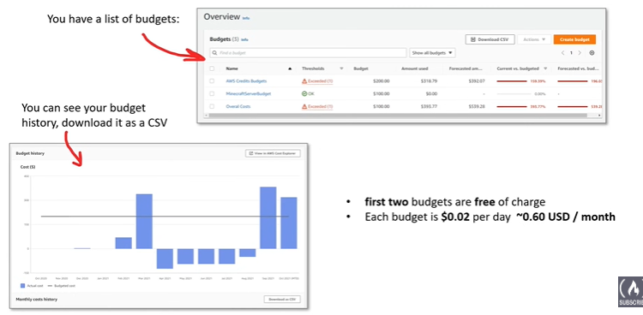

AWS Budget Reports: 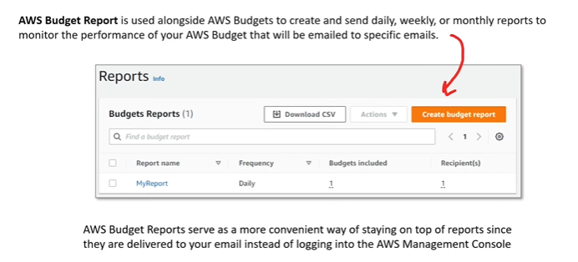

AWS Cost and Usage Reports (CUR):

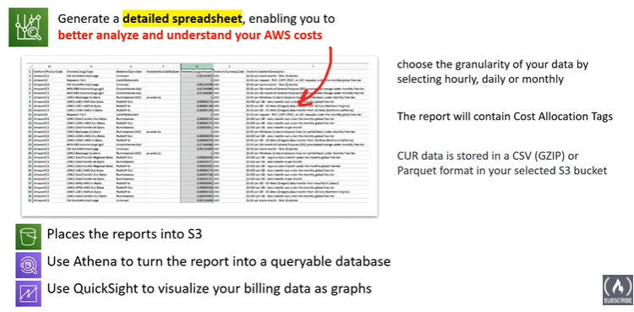

Cost Allocation Tags: 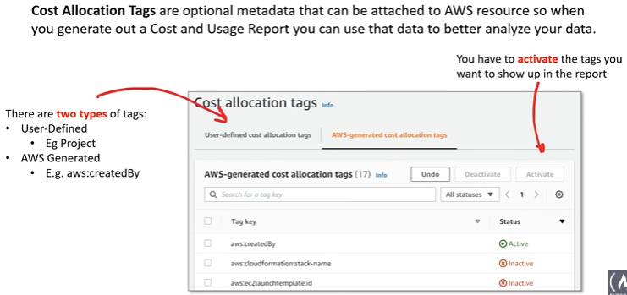

Billing Alarms: 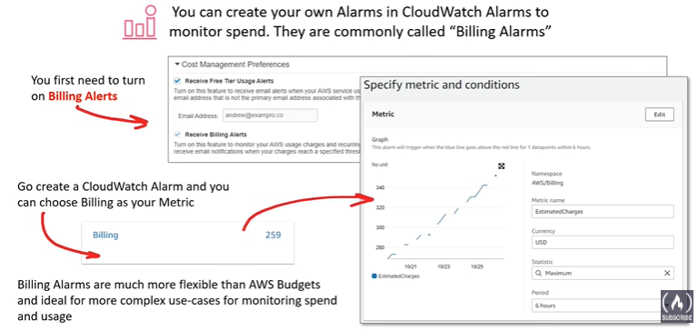

AWS Cost Explorer: 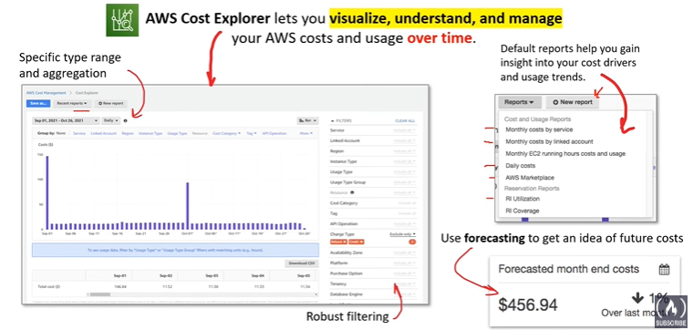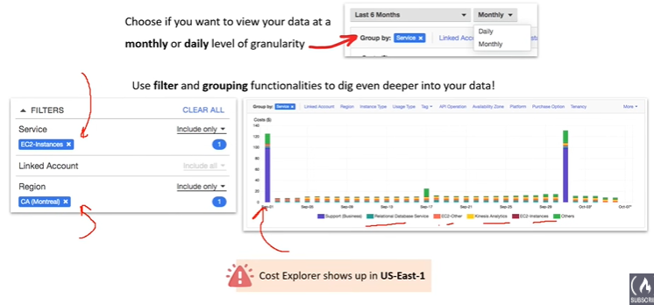

Programmatic Pricing APIs: 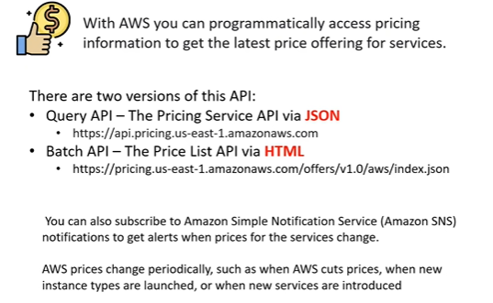

Defense In Depth: 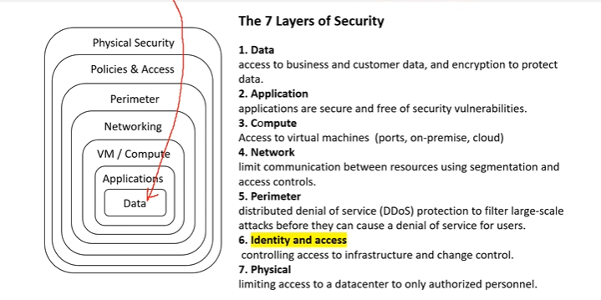

CIA(Confidentialty, Intregrity and Availiablity) Traid: 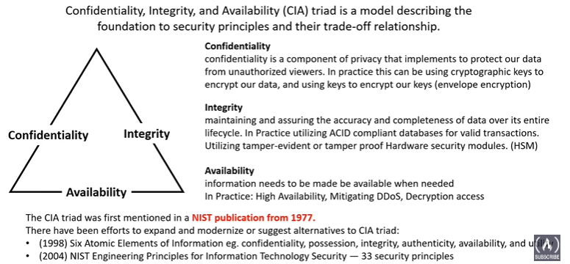

Vulnerabilities: 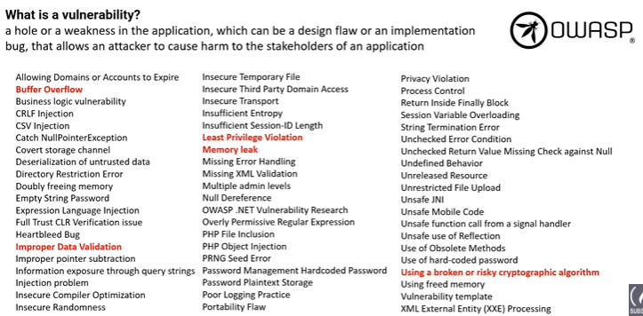

Encryption: 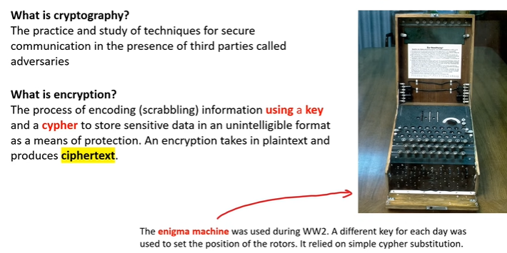

Cypher: 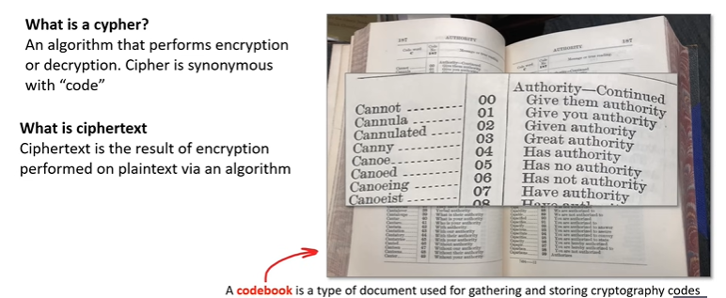

Cryptographic Keys: 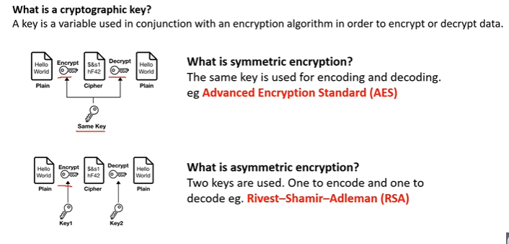

Hashing and Salting:

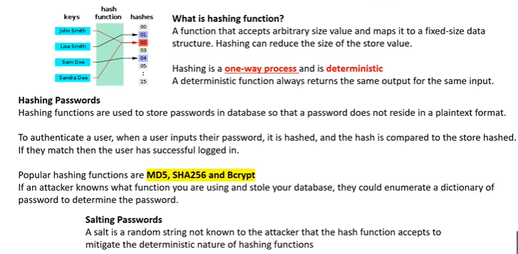

Digital Signature and Signing: 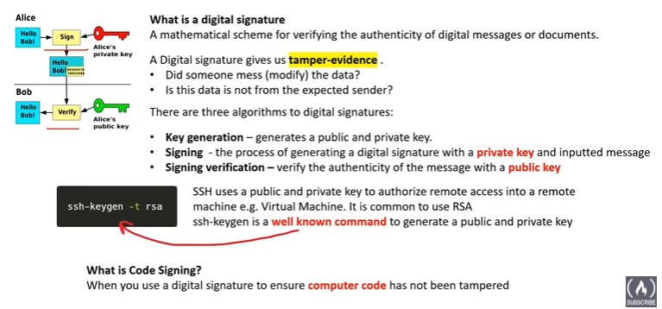

In Transit vs At Rest Encryption: 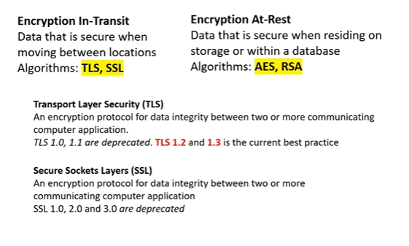

Compliance Programs: 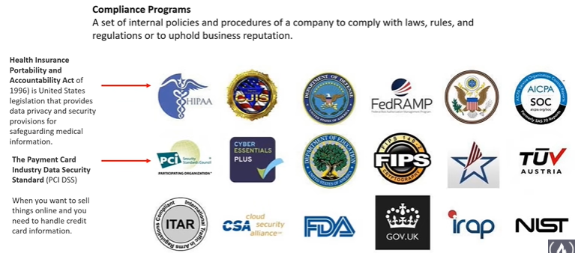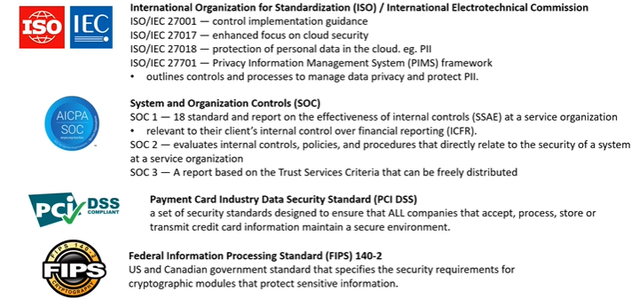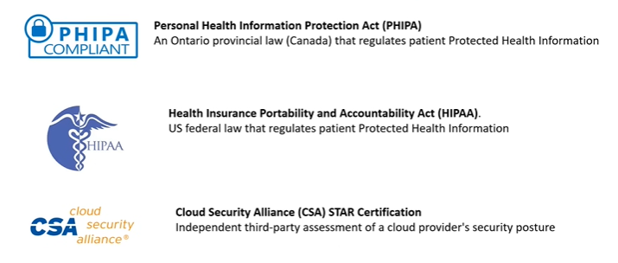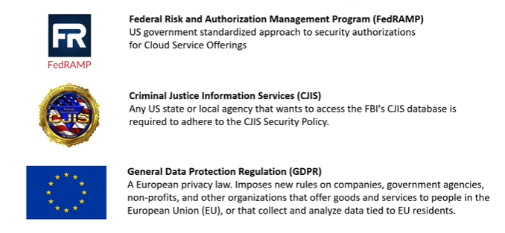

Penetration Testing: 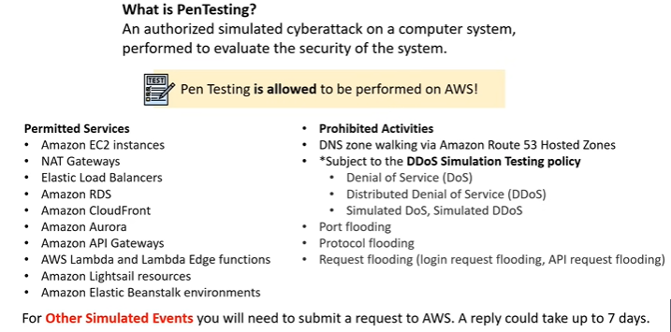

AWS Artifact:

AWS Artifact is basically a **self-service portal where you can download documents related to the security and compliance of AWS** and the services you use on it. Imagine it like a library specifically for official documents about AWS. 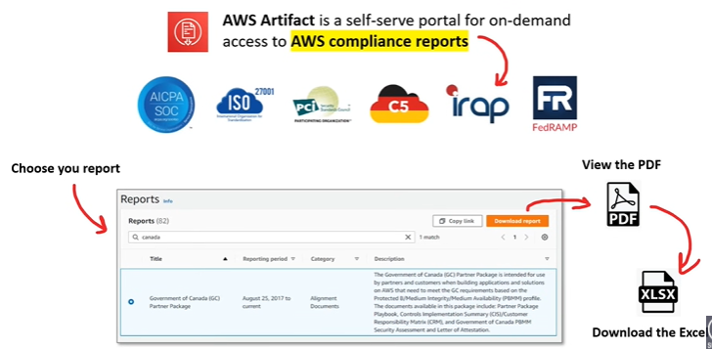

AWS Inspector: 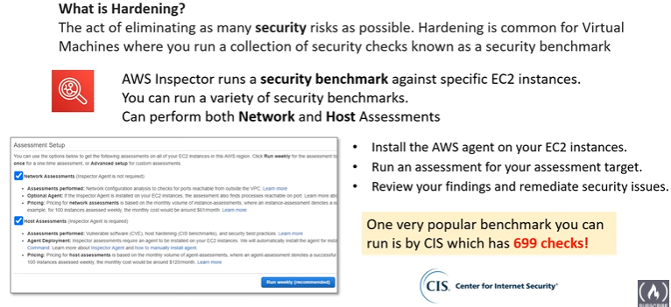

DDoS: 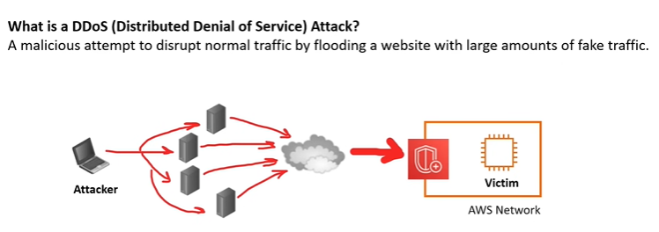AWS Shield: 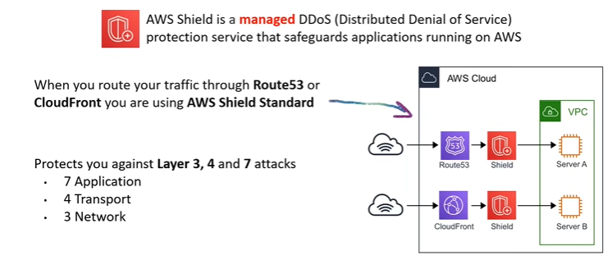

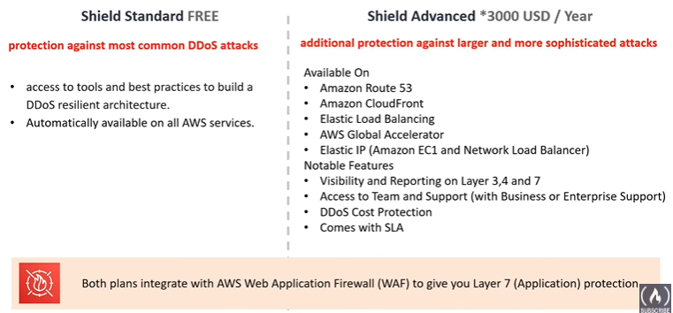

AWS Guard Duty: 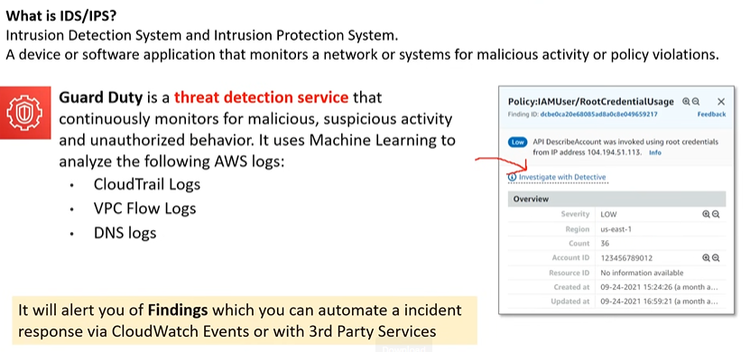

Amazon Macie: 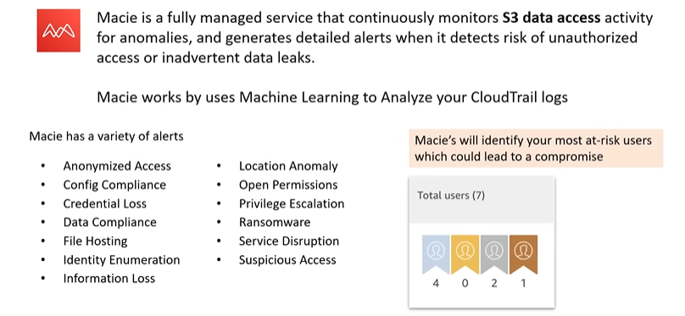

AWS VPN: 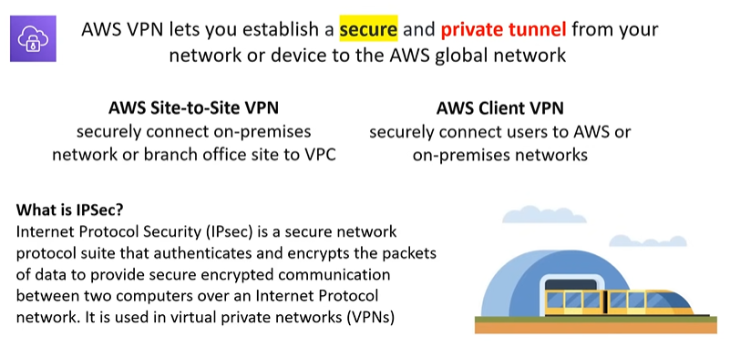

AWS WAF (Web Application Firewall): 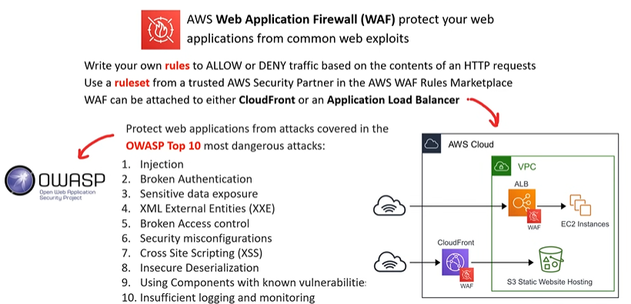

Hardware Security Module: 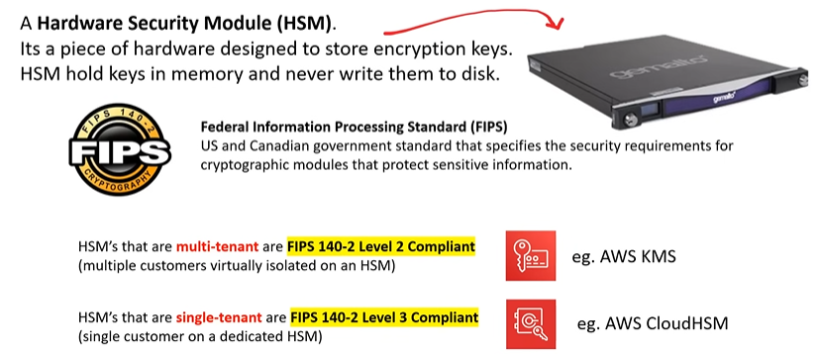

AWS KMS (Key Management Service): 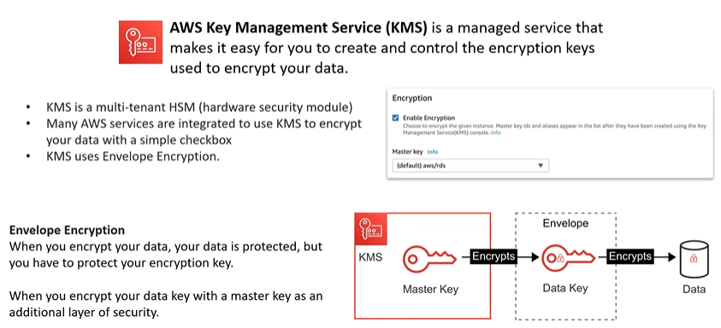

CloudHSM: 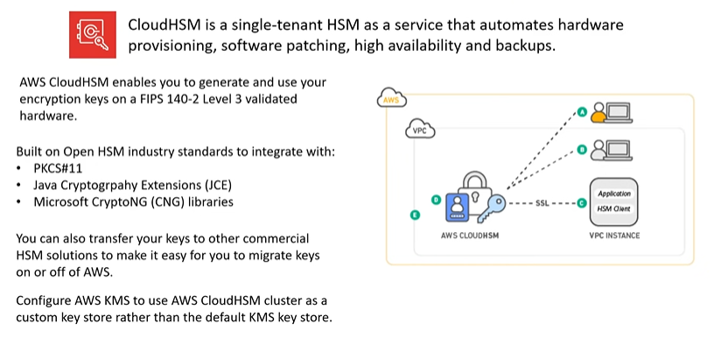

Know You Initialism: 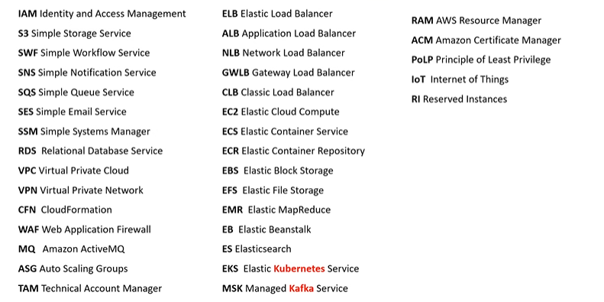

AWS Config vs AWS App Config:

* **Use AppConfig if:** You need to manage and deploy application configurations safely and dynamically.
* **Use Config if:** You need to track resource configurations, ensure compliance, and automate remediation of deviations.

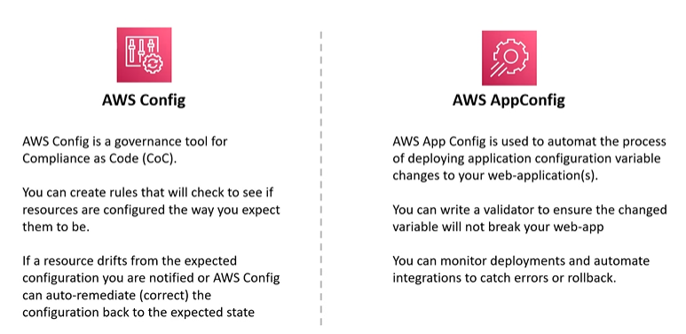

SNS VS SQS: 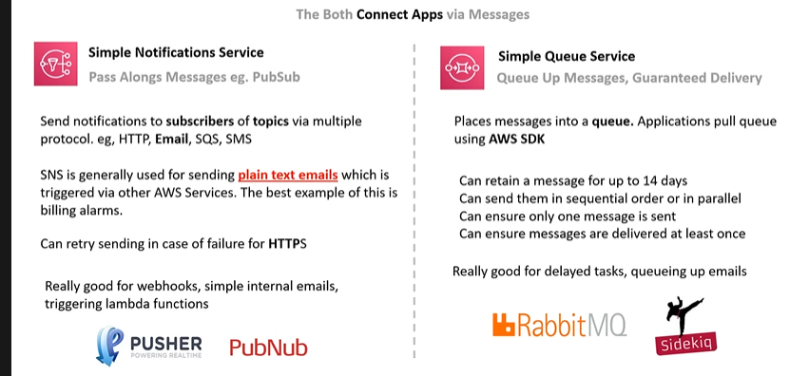

SNS vs SES vs PinPoint vs Workmail: 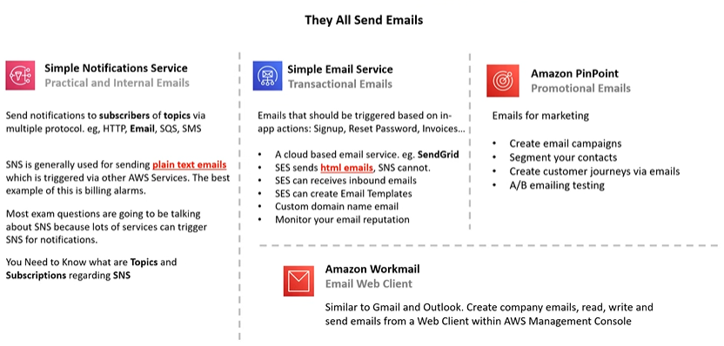

AWS Inspector vs AWS Trusted Advisor: 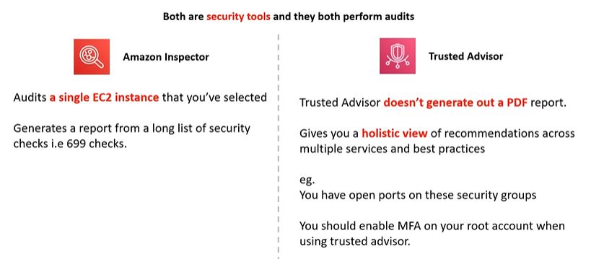

Connect Named Services: 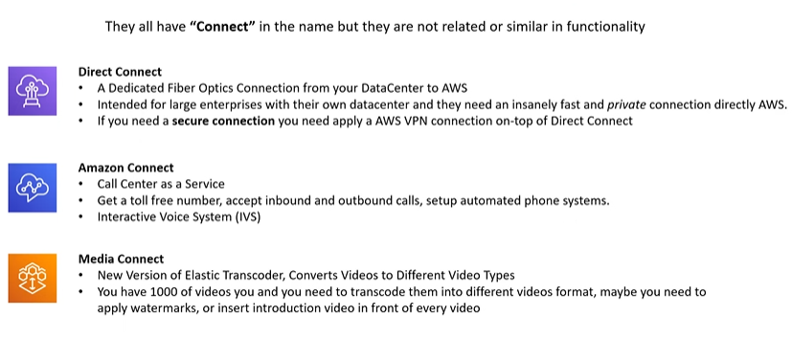

Elastic Transcode vs Media Convert: 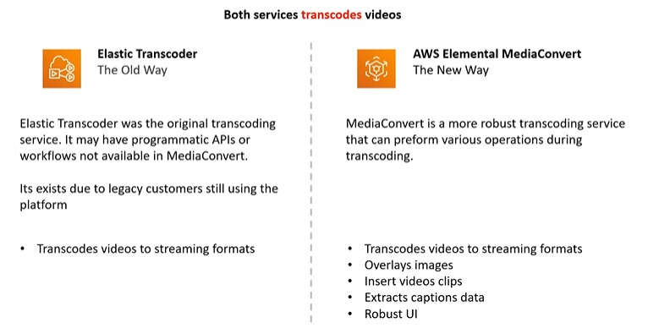

AWS Artifact vs Amazon Inspector: 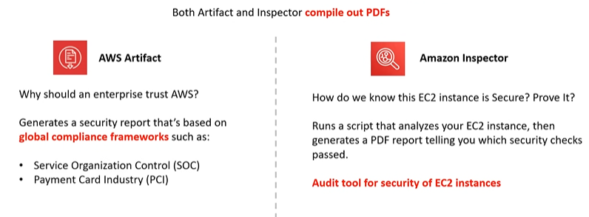

ELB vs ALB vs NLB vs GWLB vs CLB: 